Foxfield School

Together we L.E.A.R.N.

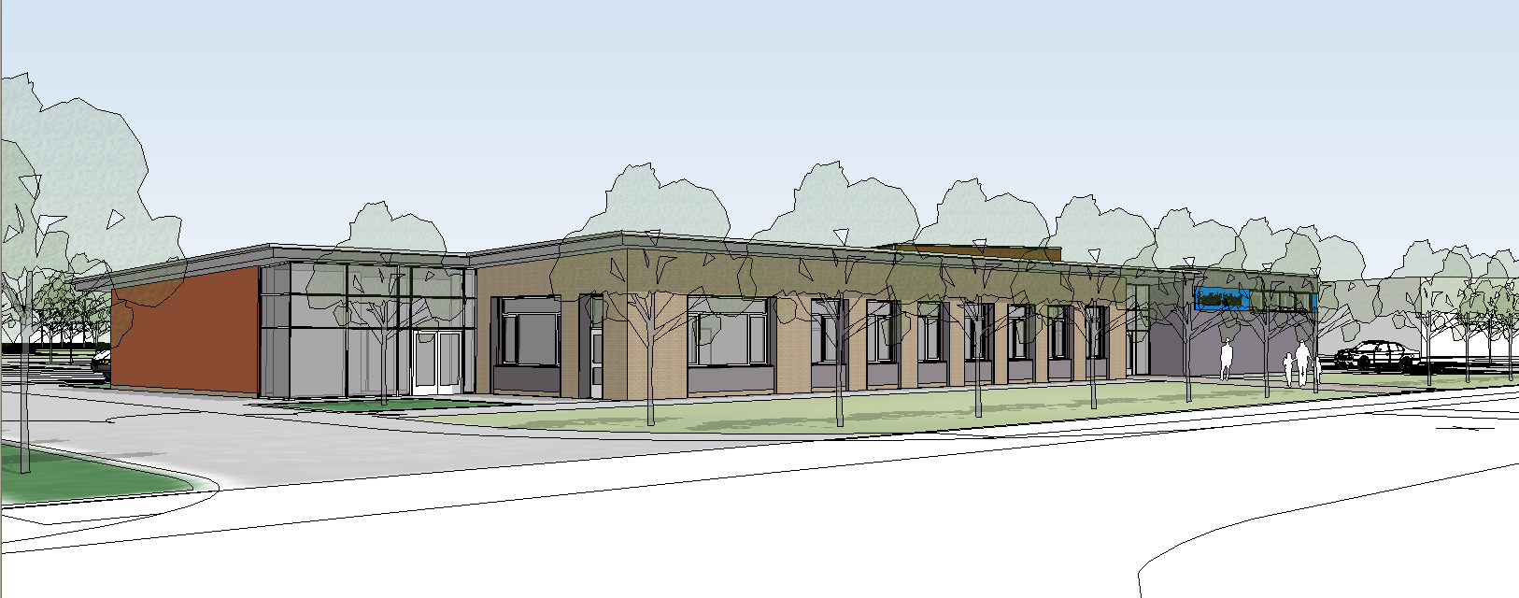
Information for visitors and contractors

Updated 29/01/2020
WELCOME TO FOXFIELD SCHOOL

HEALTH & SAFETY INFORMATION

To ensure the safety of yourselves, our pupils, staff and visitors, we would ask you to make yourself familiar with our Safety Rules and information.

FIRE

Evacuation Procedure
- The fire alarm sound is Spoken Announcement
- On hearing the fire alarm, you will be required to evacuate your place of work by the nearest safest route
- Assemble at the assembly point AT THE FAR RIGHT HAND CORNER OF THE PLAYGROUND BY THE MINIBUS PEN.
- Do not leave the site during an emergency unless given permission to do so.
- Do not move vehicles unless given permission to do so
- Do not re-enter the building unless given permission to do so.
- It is the responsibility of the Principal Contractor or his deputy to complete the roll call and inform Head Teacher/Deputy that all persons are accounted for.

Action on Discovery of Fire
- Raise the alarm
- Evacuate your place of work by nearest safest means
- Do not attempt to tackle the fire
- Muster at nominated assembly point.

Please note: The fire alarm is tested BEFORE THE SCHOOL DAY. The test will normally only last less than a minute. IF IN DOUBT, GET OUT!

ACCIDENTS

ALL accidents must be reported to your immediate supervisor and it is the responsibility of the Principal Contractor to ensure that the appropriate reports are completed. The Principal Contractor should report accidents which occur on the school premises to the Head Teacher OR Deputy Head Teacher as soon as possible after the incident.

FIRST AID PROVISION

The school should advise contractors whether they are prepared to administer first aid. If you decide you do not wish to, the Contractor must make their own arrangements.

VEHICLES ON SITE

Where it is a requirement to bring Commercial vehicles on site during the school day, i.e. for the purpose of delivery of materials/equipment, the Principal Contractor should obtain prior permission from the Head Teacher or Deputy. A banks man must be available to direct the vehicle safely onto the site.

ACCESS TO SCHOOL

If access is required onto the school premises, the contractor must report to Reception and obtain permission.

SMOKING

Smoking is not permitted on the premises.

SITE SAFETY

We would ask all contractors and their employees to maintain the highest standards of safety at all times.

Thank You for your cooperation

Mr. A.Baird
Headteacher

Safety Information for Contractors
Foxfield School

I confirm that I have read the School’s Safety Information sheet and agree to comply with the requirements of the School’s Safety Policies and Procedures.

Name: | Employer | Signature | Date

