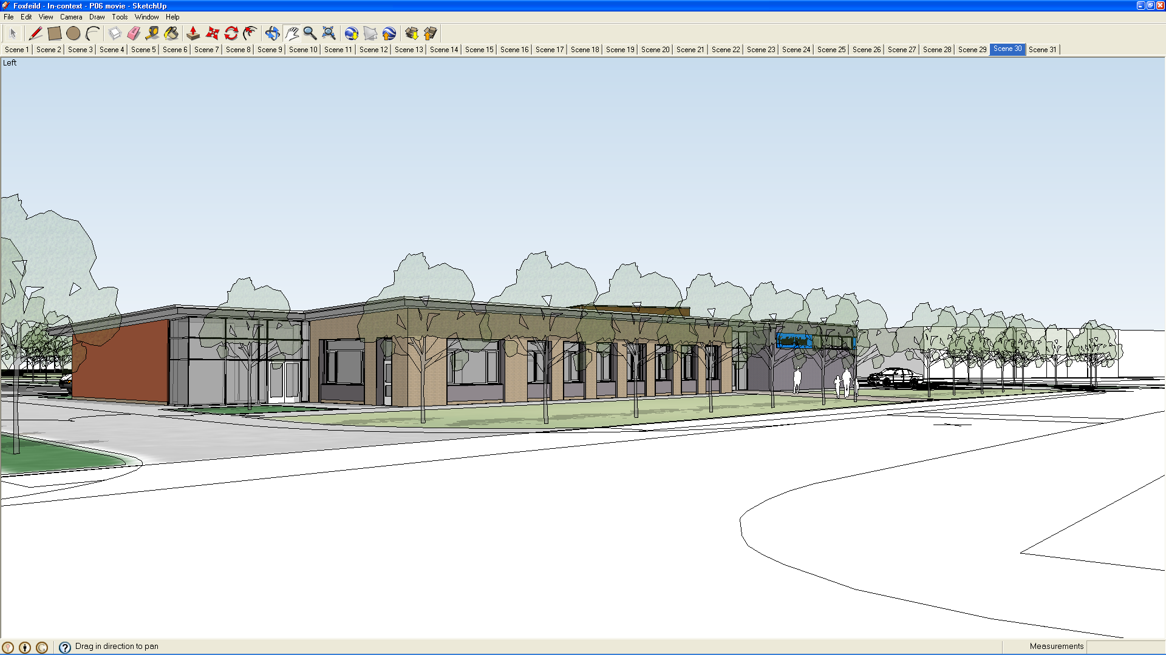

GENERAL

Both vehicles are serviced once a year by a garage. The buses are checked each time they are used by the driver, completing the log of maintenance, repair and checks. The buses are registered as Disabled Passenger Class, and both have Blue Badge permits. Each bus has a yearly M.O.T. which because of their size must be done at a P.S.V. testing centre not a garage.

WHO CAN DRIVE?
The Driver is solely responsible for the Bus on the Highway. Only drivers who have been assessed and have passed the Minibus Drivers Assessment Scheme (M.I.D.A.S.), the local authority assessment scheme or hold a current PSV Licence can drive the buses to transport Foxfield pupils. Drivers without the D1 clasification on their licence are not eligible to drive minibuses or to take part in the minibus training. The School cannot allow staff to use the bus who have not been through one of these schemes. Please see the Deputy Head responsible for health and safety about any questions to do with eligibility for driving.

School Minibus
Procedures and Protocol
2020

OTHER RESPONSIBILITIES

The driver is responsible for checking the basic functioning of the vehicle. A checklist for each use is kept in the bus (see appendix). It is important to remember that this check must be completed each time a different driver uses bus.

EQUIPMENT
The buses must contain a
Two Fire Extinguishers, First
Aid box and seatbelt cutters. These have been Fitted.

First Aid Boxes
Contents;
- 10 antiseptic wipes
- one conforming disposable bandage
- two triangular bandages
- one packet of assorted adhesive dressings
- three large sterile unmediated ambulance dressings (not less than 15cm x 20cm )
- two sterile eye patches with attachments
- one pair rustless blunt – ended scissors

The Blue (Fiat Ducato) and Green Buses both contain clamps for fitting wheelchairs, and also an inertia reel seat belt. These must always be used when transporting wheelchairs. Therefore, four clamps (2 front, 2 back) and the seatbelt for each chair will be needed. These must only be fitted by a competent member of staff and checked by the driver.
NB
The Wheelchair lap strap is not sufficient on its own

Exits to the bus must not be obstructed.

Please seek advice on use of clamps and tail lift if you are not sure.

BREAKDOWNS/FAULTS
Any faults must be reported immediately to the Head or a Deputy. The bus must not be driven if there is any problem with safety.

BLUE BADGE SCHEME

If you intend to use the pass (it is kept in the Minibus File in the Office and can be collected with the keys).
A copy of the instructions is kept with the badge. It does not entitle you to park anywhere – there are restrictions. (See notes with badges)

INSURANCE COVER
The buses are insured fully comprehensively, however, there are some restrictions.
- Drivers must be over twenty - one.
- Drivers must declare any traffic convictions.
- Buses must be used on school business e.g. educational visits and trips, integration etc.

SAFETY

SEATBELTS
These should always be worn by pupils and staff. There are 3 types: Lap straps, Full harness (These should be used according to pupil size or particular needs and should be only used after completion of a referral from the Authority Occupational therapist [see Manual handling Policy]).
Seatbelts should be worn as tightly as possible. Lap belts are not recommended but if worn should be worn across the top of the thighs, NEVER across the stomach.
Movable inertia reel belts for wheelchairs
To fix a wheelchair in the buses requires:

Clamping both sides of the chair to the floor using the special clamps/ straps.

Clamping the inertia reel on one side and the anchor point on the other.

NB
There are a total of four anchor points per chair. In addition, the pupil should have their wheelchair lap strap on and the wheelchair brakes must be off.

MANOEUVRING
Staff should always ensure it is safe to reverse and use another member of staff to help.

TAIL LIFT
Great care must be exercised getting pupils on and off the lift. Do not rush the operation
Ensure the chair brakes are on and a member of staff is on the lift behind the chair. Also ensure that the flap on the rear of the tail lift is in the up position ensuring that the chair will be stopped if it rolls back.

NB
Although this flap prevents the chair rolling back it clearly presents a hazard to the member of staff who may trip over it.

(See minibus tail lift risk assessment for further details).

REAR DOORS

Must always be unlocked when carrying passengers

SEATING
If you intend to take seats off any of the buses you should allow time on your return to be able to replace all the seats ready for the next group, unless you have made special arrangements with the following group to leave them off. Taking off and replacing seats are not the responsibility of the caretaker, technician etc. these procedures should be carried out by classroom staff.

(See minibus risk assessments for further details on the removal and replacement of seats).

DRIVING HOURS
For a journey over two hours, regular stops for toilet, fresh air and refreshment should be built in to the trip. Journeys of any greater length may need a second driver. Planning must take this into account.

ACCIDENTS
If there is an accident resulting in injury, damage to any vehicle, injury to an animal (horse, cattle, ass, mule, sheep, pig, goat or dog) the driver must;

Stop;

Give their name and address, the name and address of the owner of the vehicle, and identification marks of the vehicle to any person(s) having reasonable grounds for requiring them.

If, for any reason, the particulars are not given at the time of the accident, then the circumstances must be reported to a police constable or at a police station as soon as possible and in any case within 24 hours.

The following routine must be adopted in case of accidents:

- If any person is injured, seek assistance and send for the police and ambulance;
- Try to obtain the names and addresses of witnesses;
- Do not admit responsibility for the accident to the other party or witnesses;

Obtain the following information:

- Name and address of the other driver (a);
- Name and address of the other vehicle owner(s);
- Registration number of other vehicle(s), type and colour;
- Name and address of the other drivers insurance company.

As soon as possible, while the events are still clear, prepare a rough report (on a school incident form) indicating:

- Extent of damage to all vehicles involved;
- Time the accident occurred;
- Where the accident occurred including; the locality;
- Names of streets and roads adjacent; position of vehicle(s) at the time of the accident;
- Visibility and weather conditions at the time of the accident.
- Cause of accident (including any information as to whether signals were given):
- Rough sketch to emphasise the general situation.

It is essential that the driver has the relevant information to allow contact, particularly out of school hours to report accidents and emergencies to the nominated manager/contact person.

The driver must ensure that the insurance policy on the vehicle covers the activity being undertaken. Those vehicles insured through the council carry a £500 accidental damage excess and are covered for use of the vehicle on school / youth club business only. Particular care should be taken in determining the insurance cover on hired and borrowed vehicles.

Booking procedure

Staff wishing to use the bus for regular time tabled curriculum related activities must do this with the deputy head teacher at the beginning of the academic year. A time table will then be produced that will be the guide for the buses use throughout the year.
Staff wishing to use the buses for one off events must first check the time table and then negotiate with the staff that the bus is timetabled for. Once negotiation has taken place staff must then write this in the mini bus timetable, counter signed by the class who held the original booking.
The acceptations to this are residential trips, these trips take priority over time tabled allocations.

Using the bus
It is the responsibility of class staff to ensure that the bus is ready and in a suitable condition to use. Any issues must be reported to the Deputy Headteacher immediately.
On returning the bus must be brushed out (to prevent build up of dirt in the runners), Seats replaced (if moved) and seat belts placed in the buckles.

The bus should be;
- Clean & runners clear of dirt
- All passenger seatbelts returned in their buckles when not in use
- Documentation complete each time it is used.

Staff that divert from this policy without prior approval from Headteacher could face disciplinary action and withdrawal of mini bus access.

