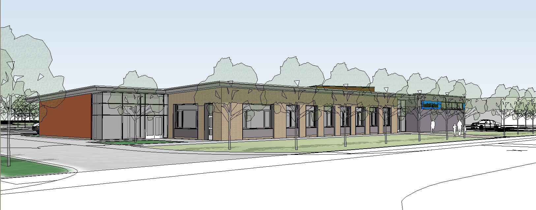

NEW STAFF

Foxfield School’s aim is to ensure that all new staff are introduced into the school in a planned, supportive and developmental way. The Headteacher and Deputy Headteacher will have planned meetings with new staff, to discuss how they are settling in, to address any problems or concerns and to ensure that the appropriate guidance and policy documents have been read and understood.

Every member of staff will have access to the School website which contains a wealth of guidance and directives on school policy and practice. The website gives guidance on a variety of issues relating to the school and is regularly updated All new staff are also advised to read the school prospectus which is also available on the School Website .

Induction Policy 2020

All aspects of school life are planned, discussed and reviewed
through the meeting schedule that operates within the school and all new staff will become involved in this process. This includes weekly briefing meetings, whole school staff meetings, school development plan meetings, age phase meetings and school twilight and full day staff training activities.

TRAINING NEEDS

The initial and ongoing training needs of new staff will be identified within the performance management systems that operate at Foxfield. The school is committed to continuing professional development for all staff. Any immediate training that a new member of staff requires will be identified through an initial audit and then provided in an appropriate way as soon as possible.

INDUCTION PROCESS

Initial Induction Meeting

The Head Teacher will initially meet with the new members of staff to greet them and welcome them to the school. In this Initial Induction Meeting he will discuss a number of key documents which staff must read. He will give each new member of staff paper copies of these documents and in this meeting will go through each of the documents pointing out key points in each. These key factors are designed to let new members of staff know what is expected of them and to inform them so that they are aware of certain procedures and protocol.
This initial pack contains the following policies:
- Staff Behaviour Policy and Code of Conduct,
- Child Protection and Safeguarding Policy,
- Keeping Children Safe in Education,
- Fire Safety Policy,
- Management of staff absence and return to work procedures,
- Acceptable use of social networking websites policy
- Guidance for safer working practices for those working

with children and young people in education settings.

Additionally the Head teacher will point out that the school has an Occupational Health Provider whom they can contact in confidence for a number of personal matters based on employee assistance.

The second part of the process follows on from the Head Teachers initial induction and aims to make new employees aware of other important documentation and policies.

At this point the staffing structure of the school is discussed so that staff know who to go to if they have a particular problem in a certain area (See appendix 1) Additionally new employees will be introduced to some of the terminology used at school of which they may not be aware and of procedures that are undertaken throughout the year (See Timeline Appendix 2 and Appendix 3). Additionally new employees will be given some safeguarding training and advice and will watch a video which will be followed by a discussion.

Other aspects of Induction will include further policies and guidance which can be discussed once the new member of staff has started to settle into the post, but certainly within their first term at Foxfield.

Having completed the process of Induction, further support will be continuous and when required, from the Deputy Head Teacher and / or Head Teacher. A ‘Need to know list’ (See appendix3)
will need to be discussed so that new staff become familiar with certain paperwork tasks such as:
how to fill in an accident and incident report form, risk assessments and how to write them, I.E.P.’s, behaviour plans, manual handling plans, absence procedures etc.

Occasionally the Head Teacher will also meet with new members of staff to make sure they are settling in and are happy in their role. This will particularly be the case when the new member of staff is a newly qualified teacher. In these cases the Head Teacher, Deputy Head Teacher or Mentor will meet and monitor progress on a regular basis to guide the member of staff through their induction year.

If the member of staff is a teaching assistant taking up a new role then the mentor is more likely to be an experienced teaching assistant (Level 3), however they will still be required to meet with the Deputy Head Teacher from time to time who will oversee the whole process to make sure the induction is progressing successfully.

Additionally at this meeting the new member of staff will be given a Continual Professional Development File (CPD) and its purpose and possible future contents discussed, together with discussions about any professional development courses staff would like to undertake in the future. Particular focus here will be on developing knowledge of Autism and PMLD.

Discussion then needs to take place about the future progression of the induction process. Time will need to be allocated for the member of staff to meet with other members of their class team on a regular basis and with the Head of the Key Stage and induction will then need to be planned specific to that member of staff and their role within the class and the Key Stage. In the case of the new member of staff being a teaching assistant the class teacher and Head of Department need to continue their support over an extended period of time. In the case of the new member of staff being a teacher it will be the Head of Department, Deputy Head and Head Teacher who need to carry on an extended period of time.

All new staff will need to organise a meeting with the ICT Technician very soon after starting at the school. The technician can then set up passwords etc for the new staff member and show them some of the more important features of the school intranet system such as accessing and adding reports into the Sleuth Behaviour Management recording database, and accessing other important information.

As the induction process progresses staff will be introduced to new processes and procedures (See Induction Timeline appendix xxx)

INDUCTION DAYS DURING THE FIRST TERM

Further training days will be arranged during the year which will include the following; Teaching Assistant Induction Day led by experienced Teaching Assistants (Level 3), Lifeguard Training, Manual handling, online safeguarding training (completion of online course and a test that must be passed in order to gain certification), Communication and Makaton training from the Communications Coordinator, information on syndromes and
other medical information led by the School Nurse and Restrictive Physical Intervention Training (RPI or Team Teach) which is a two day course.

Additionally staff who have been driving for more than two years and hold a D1 licence will be given the opportunity to receive training and complete a school minibus test if they so wish.

As part of their induction and indeed throughout their school career all staff will be given the opportunity to attend local and national training to suit the needs of their role from NVQ’s to post graduate qualifications.

All classroom staff will be required to attend school INSET days and staff meetings (full time only), which will include additional training and CPD.

As part of induction process new staff need to meet with a number of people for information and guidance (See Appendix 4) This list is a guide and gives details of who to ask about certain procedures and terminology.

Appendix 5 is a tick list to be filled in for your own records as policy documents are read.

Appendix 1

Staff structure

Headteacher
Mr. Andre Baird

Deputy Headteachers
Mr. Paul D. Howley

Senior Management Team

Assessment Recording and Reporting - Mr. I. Harwood

Head of Key Stage 3, Whole School Communication – Mrs. M. Ijewsky

Head of Key Stage 4, Maths Coordinator - Miss R. McBride

Head of Post 16, ILS Coordinator
– Mrs R. Hulme

Curriculum Coordinators and TLR Roles

Science and PSHE & C/SRE – Mrs. R. Cuthill

Behaviour Management Coordinator – Mr. S. Ledson

English Literature – Mrs. E.Wall

Computing and Performing Arts – Mr. I. Harwood

Humanities including Religious Education – Miss. L. Gorton

Enterprise and Careers Education – Mrs. D. Karythis

Coordinator for Home / School
Communications – Mr. I Harwood

Coordinator for Music and Art – Miss R. Smyton

Coordinator for Behaviour Management – Mr. S. Ledson

Swimming Coach – Mr. G. Langford

Extra Curricular Activities
– Mr. G Attwood

Pupil Consultation and Involvement,
including School Council
– Mrs. D Roche

Sensory Leader and Leader
for PE – Mr. G. Attwood

Autistic Spectrum Condition Leader
– Mr A. McAteer

Building, Communication and
Technology Technician – Mr. P. Dutton

Appendix 2

Induction and Training Timeline (Teachers only)

September | October | November | December | January | February

EVOLVE, M13
SLEUTH, IBP’s, I.E.P’s
IEP’s, Lesson Observations & Appraisal
Parents evening - Do’s and Don’ts
Teacher planning
Annual Reviews

Assessment – Do’s and Don’ts

Progress Files

Annual Reports

Preparing for parents evening
Analysing assessment results

March | April | May | June | July

Individualised Induction Process
Phase 1 – Initial Induction Meeting and Greeting by Head Teacher

Phase 2 – What you need to know - Documents, Web site and information + Safeguarding video and discussion + where to find specific information on the system, explanation of CPD files and requests

Phase 3 – Training videos and work schedule timelines

Phase 4 - (NQT and RQT Teachers only) – Merseyside schools additional training

Phase 5 – Personalised training from Training Providers after discussion with Deputy Head Teacher

Phase 6 – On going in – house CPD sessions via staff meetings, INSET days and Twilight sessions

Appendix 3

Induction Procedure: Things you need to know about at Foxfield
Staff structure
Intranet
Web Site
IEP’s
Annual Review procedure
Briefing meetings
Bulletin
Pupil permissions
Evolve Forms
Risk Benefit Assessments
Curriculum overview
Residentials
ASDAN
Meetings
Subject coordinator responsibilities
Routines for start and end of day
Assemblies
Teacher record files
Behaviour plans
Care plans
Medical information
Progress files
Accident procedures
Late Bus groups
Incident forms – M13
Merit systems (Class based and Assembly)
Booking of equipment, rooms and buses
Citizenship awards
Speech Therapy
Occupational Therapy
Physiotherapy
Staff absence procedures
Policy Documents
Blue Badge Scheme
Staff working hours
Term dates for coming academic year
RPI (Restrictive Physical Intervention) - Team Teach

Appendix 4

Who you will need to meet with in your first term (tick when completed)

Checklist for induction procedure - Teachers

[ ] Deputy Head (Paul) regarding curriculum leadership responsibilities

[ ] Head of your particular Key Stage re Key Stage organisation and related issues

[ ] Assessment Recording and Reporting (AR&R) coordinator re guidance and completion of a variety of AR&R documents in school

[ ] If teaching ASDAN at KS4 or post 16 (6th form) you will need to see the ASDAN coordinator

[ ] The senior teacher for Behaviour Management to arrange physical intervention training

[ ] ICT Coordinator / ICT Technician

[ ] Coordinators for Foundation Learning – Personal Progress and PSD)

[ ] In addition feel free to ask to meet any other staff who may have information useful to you e.g. Medical staff, subject leaders etc.

Checklist for induction procedure – Support Staff

[ ] Head of your particular Key Stage re Key Stage organisation and related issues

[ ] The senior teacher for Behaviour Management to arrange physical intervention training

[ ] ICT Coordinator/ ICT Technician

Appendix 5 - Policy Documents Check

 | Tick |  | Tick
Acceptable use of social networking websites policy |  | Needle stick injury
Administration of medications during residential trips |  | Parental involvement
Admissions & Attendance Registers Policy |  | Performance Management Policy
Aims of the school |  | Planning, assessment, recording and reporting
Allergy Policy |  | School transport policy
Anti - Bullying Policy |  | Security (Including lockdown procedures)
Asthma Policy |  | Sensory policy
Behaviour Policy |  | Staff behaviour policy
CCTV Policy |  | Staff and pupil health and hygiene
Child Protection and Safeguarding |  | Stress management
Data Protection Policy Document |  | Supervision policy
Dealing with extremism and radicalisation |  | Teacher planning
Educational Visits Policy |  | Teaching and learning policy
Emergency Action Plan, Swimming Pool |  | Visitors policy
Fire Safety |  | Volunteers policy
First Aid |  | Whistle blowing policy
Health and Safety Policy |  | Whole school planning policy
Home – school agreement policy |  | Work related and enterprise policy
ICT Resource deployment policy
ILS Policy
Incidents and accidents
Lone workers policy
Learning Outside the Classroom (LOtC)
Management of sickness absence policy
Manual handling
Minibuses
Missing pupil procedures
Mobile phones

Please tick box when read so you know which one you need to read next

