Disclosure and Barring Service Checks
2020
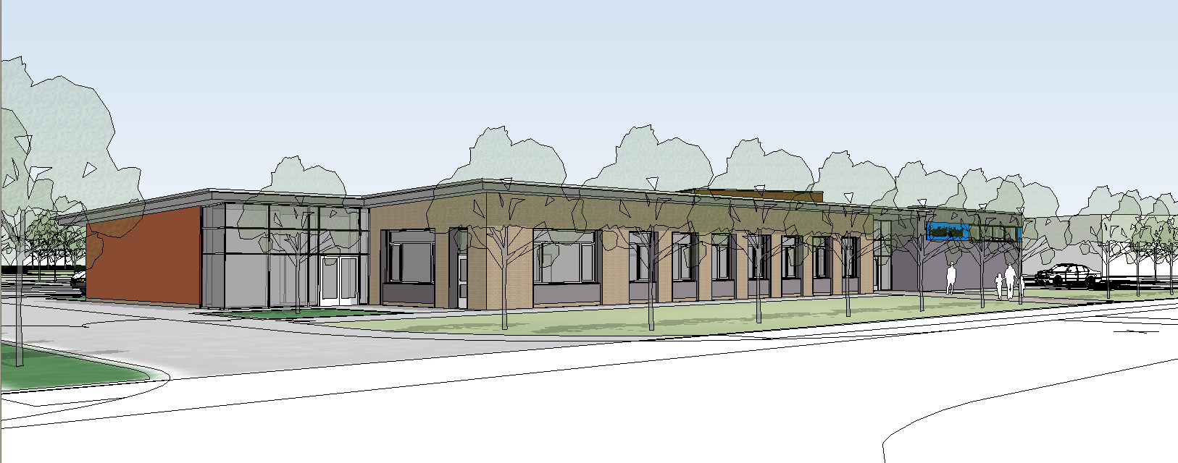

We believe this policy relates to the following legislation:

- Rehabilitation of Offenders Act 1974
- Data Protection Act (1998)
- Human Rights Act (1998)
- School Standards and Framework Act 1998
- Immigration, Asylum and Nationality Act 2006
- Safeguarding Vulnerable Groups Act 2006
- Education (School Teachers) (Qualifications and Specified Work) (Miscellaneous Amendments) (England) Regulations 2012
- Protection of Freedoms Act 2012

The following documentation is also related to this policy:

- Conditions of Service for School Teachers in England and Wales (Burgundy Book) (Council of Local Education Authorities)
- Keeping Children Safe in Education: Statutory Guidance for Schools and Colleges (DfE)

We have a statutory duty of care to safeguarding the welfare of children and vulnerable adults and providing them with a safe learning environment. By undertaking checks via the Disclosure and Barring Service (DBS) for those people who are looking to work with children, we aim to prevent unsuitable people from working with children and vulnerable adults.

The DBS provides the following checks namely:

Standard check: records of convictions, cautions, reprimands and warnings as found on the Police National Computer (PNC)

Enhanced check: as above plus other relevant information held by the police

Enhanced check with a Barred List check (child) and Enhanced check with a Barred List check (adult). Those people who are deemed unsuitable to work with children and vulnerable adults are placed on to either the Children's Barred List or Adults' Barred List.

We realise that the majority of school appointments are for personnel who will be responsible for the care and supervision of children on a regular basis (regulated activity) and as part of the process of safe recruitment all prospective employees will need to have an enhanced DBS check with barred list information. The level of check will be appropriate for the post or type of work undertaken. We have a mandatory duty to make checks for anyone who will be in regulated activity.

We are aware that we do not have the power to request DBS checks and barred list checks or ask to see DBS certificates for visitors. However all visitors are required to enter their names in the signing in book and

collect a visitors badge before being allowed to enter the main body of the school. Doors to the main school can only be opened by releasing a magnetic lock which prevents unwanted visitors gaining access If visitors carry the Wirral Authority Identification Card they will be allowed

to enter the school but will generally be accompanied to their destination by a member of staff. Workmen also need to sign in and get a badge and will be accompanied around the building by a caretaker or if the caretaker is not in the building the Deputy Head will accompany the person to the job. If any person is found in the main school body without an identification badge they will be challenged by staff.

We have 'a legal duty to refer to the DBS anyone who has harmed, or poses a risk of harm, to a child, or if there is reason to believe the member of staff has committed one of a number of listed offences, and who has been removed from working (paid or unpaid) in regulated

activity, or would have been removed had they not left.' (Keeping Children Safe in Education: Statutory Guidance for Schools and Colleges (DfE))

We will consider any person with a criminal record equally with others applying for any vacant post at this school unless their DBS checks indicates that they present a risk to children.

We as a school community have a commitment to promote equality. Therefore, an equality impact assessment has been undertaken and we believe this policy is in line with the Equality Act 2010.

We believe it is essential that this policy clearly identifies and outlines the roles and responsibilities of all those involved in the procedures and arrangements that is connected with this policy.

Aims

- To provide protection for children and vulnerable adults against those who might wish to harm them.
- To protect the interests of the school from those who may not be considered
- suitable to work with pupils and vulnerable adults.
- To share good practice within the school.
- To work with other schools to share good practice in order to improve this policy.

Responsibility for the Policy and Procedure

Role of the Governing Body

The Governing Body has:

- delegated powers and responsibilities to the Headteacher to ensure DBS checks are in place;
- delegated powers and responsibilities to the Headteacher to ensure all school personnel and visitors to the school are aware of and comply with this policy;
- responsibility for ensuring that the school complies with all equalities legislation;
- responsibility for ensuring this policy and all policies are maintained and updated regularly;
- responsibility for ensuring all policies are made available to parents;
- nominated a link governor to visit the school regularly, to liaise with the Headteacher and to report back to the Governing Body;

- responsibility for the effective implementation, monitoring and evaluation of this policy

Role of the Headteacher

The Headteacher will:

use the online DBS Update service to check the validity of DBS certificate to;
- using the disclosure check information decide whether an appointment can proceed;
- keep up to date a single central record;
- ensure all school personnel, pupils and parents are aware of and comply with this policy;
- work closely with the link governor and coordinator;
- provide leadership and vision in respect of equality;
- provide guidance, support and training to all staff

- monitor the effectiveness of this policy;
- annually report to the Governing Body on the success and development of this policy

Role of the Nominated Governor

The Nominated Governor will:

- work closely with the Headteacher;
- ensure this policy and other linked policies are up to date;
- ensure that everyone connected with the school is aware of this policy;
- report to the Governing Body every term;

Role of School Personnel

School personnel will:

- comply with all aspects of this policy;
- ensure they provide all the necessary documentation for the disclosure process;
- implement the school’s equalities policy and schemes;
- report and deal with all incidents of discrimination;
- attend appropriate training sessions on equality;
- report any concerns they have on any aspect of the school community

Single Central Record

We will keep a single central record that records the following information:

Checks | Date when checked
- Identity check
- Barred list check
- Enhanced DBS check
- Prohibition from teaching check
- Checks on individuals living or working outside the UK
- Professional qualifications check
- Right to work in the UK check

Role of Parents/Carers

Parents/carers will be made aware of this policy.

Raising Awareness of this Policy

We will raise awareness of this policy via:

- the School Handbook/Prospectus
- the school website

- the Staff Handbook
- meetings with school personnel
- reports such annual report to parents and Headteacher reports to the Governing Body

Training

All school personnel:

- have equal chances of training, career development and promotion
- receive training on this policy on induction;
- receive periodic training so that they are kept up to date with new information
- receive equal opportunities training on induction

Equality Impact Assessment

Under the Equality Act 2010 we have a duty not to discriminate against people on the basis of their age, disability, gender,

gender identity, pregnancy or maternity, race, religion or belief and sexual orientation.

This policy has been equality impact assessed and we believe that it is in line
with the Equality Act 2010 as it is fair, it does not prioritise or disadvantage any pupil and it helps to promote equality at this school.

Monitoring the Effectiveness of the Policy

The practical application of this policy will be reviewed annually or when the need arises by the coordinator, the Headteacher and the nominated governor.

A statement of the policy's effectiveness and the necessary recommendations for improvement will be presented to the Governing Body for further discussion and endorsement. (See Policy Evaluation)

Group | No contact with  children | Contact with children |  | Type of DBS check
Group | No contact with  children | Supervised | Not supervised | Type of DBS check
New member of staff |  |  |  | DBS certificate (with barred list check)
New member of staff transferring from another school without a break in service |  |  |  | No legal requirement to obtain an enhanced DBS certificate (with barred list check)
New volunteer |  |  |  | No legal requirement to obtain a new enhanced DBS certificate (with barred list check) but an enhanced DBS certificate may be obtained
New volunteer |  |  |  | DBS certificate (with barred list check) must be obtained
New volunteer |  |  |  | Not in regulated activity but an enhanced DBS certificate may be obtained
Contractors |  |  |  | DBS certificate (with barred list check) must be obtained
Contractors |  |  |  | No DBS check is required
Trainee teachers (student teachers) |  |  |  | An enhanced DBS certificate (with barred list check) must be obtained
Supply teachers and other temporary agency staff |  |  |  | An enhanced DBS certificate (with barred list check) must be obtained by the agency with written confirmation sent to the school
Governors |  |  |  | No legal requirement to obtain a new enhanced DBS certificate (with barred list check) but an enhanced DBS certificate may be obtained
Governors |  |  |  | DBS certificate (with barred list check) must be obtained
Governors |  |  |  | Not in regulated activity but an enhanced DBS certificate may be obtained

Initial Equality Impact Assessment

Policy Title | The aim(s) of this policy | Existing policy (✓) | New/Proposed Policy (✓) | Updated Policy (✓)
 |  |  | ✓

This policy affects or is likely to affect the following members of the school community (✓) | Pupils | School Personnel | Parents/carers | Governors | School Volunteers | School Visitors | Wider School Community

Question | Equality Groups |  |  |  |  |  |  |  |  |  |  |  |  |  |  |  |  |  |  |  |  |  |  |  | Conclusion
Does or could this policy have a negative impact on any of the following? | Age |  |  | Disability |  |  | Gender |  |  | Gender identity |  |  | Pregnancy or maternity |  |  | Race |  |  | Religion or belief |  |  | Sexual orientation |  |  | Undertake a full EIA if the answer is ‘yes’ or ‘not sure’
 | Y | N | NS | Y | N | NS | Y | N | NS | Y | N | NS | Y | N | NS | Y | N | NS | Y | N | NS | Y | N | NS | Yes | No
 |  | ✓ |  |  | ✓ |  |  | ✓ |  |  | ✓ |  |  | ✓ |  |  | ✓ |  |  | ✓ |  |  | ✓ |  |  | ✓
Does or could this policy help promote equality for any of the following? | Age |  |  | Disability |  |  | Gender |  |  | Gender identity |  |  | Pregnancy or maternity |  |  | Race |  |  | Religion or belief |  |  | Sexual orientation |  |  | Undertake a full EIA if the answer is ‘no’ or ‘not sure’
 | Y | N | NS | Y | N | NS | Y | N | NS | Y | N | NS | Y | N | NS | Y | N | NS | Y | N | NS | Y | N | NS | Yes | No
 | ✓ |  |  | ✓ |  |  | ✓ |  |  | ✓ |  |  | ✓ |  |  | ✓ |  |  | ✓ |  |  | ✓ |  |  |  | ✓
Does data collected from the equality groups have a positive impact on this policy? | Age |  |  | Disability |  |  | Gender |  |  | Gender identity |  |  | Pregnancy or maternity |  |  | Race |  |  | Religion or belief |  |  | Sexual orientation |  |  | Undertake a full EIA if the answer is ‘no’ or ‘not sure’
 | Y | N | NS | Y | N | NS | Y | N | NS | Y | N | NS | Y | N | NS | Y | N | NS | Y | N | NS | Y | N | NS | Yes | No
 | ✓ |  |  | ✓ |  |  | ✓ |  |  | ✓ |  |  | ✓ |  |  | ✓ |  |  | ✓ |  |  | ✓ |  |  |  | ✓

Conclusion | We have come to the conclusion that after undertaking an initial equality impact assessment that a full assessment is not required.

Preliminary EIA completed by | Date | Preliminary EIA approved by | Date

