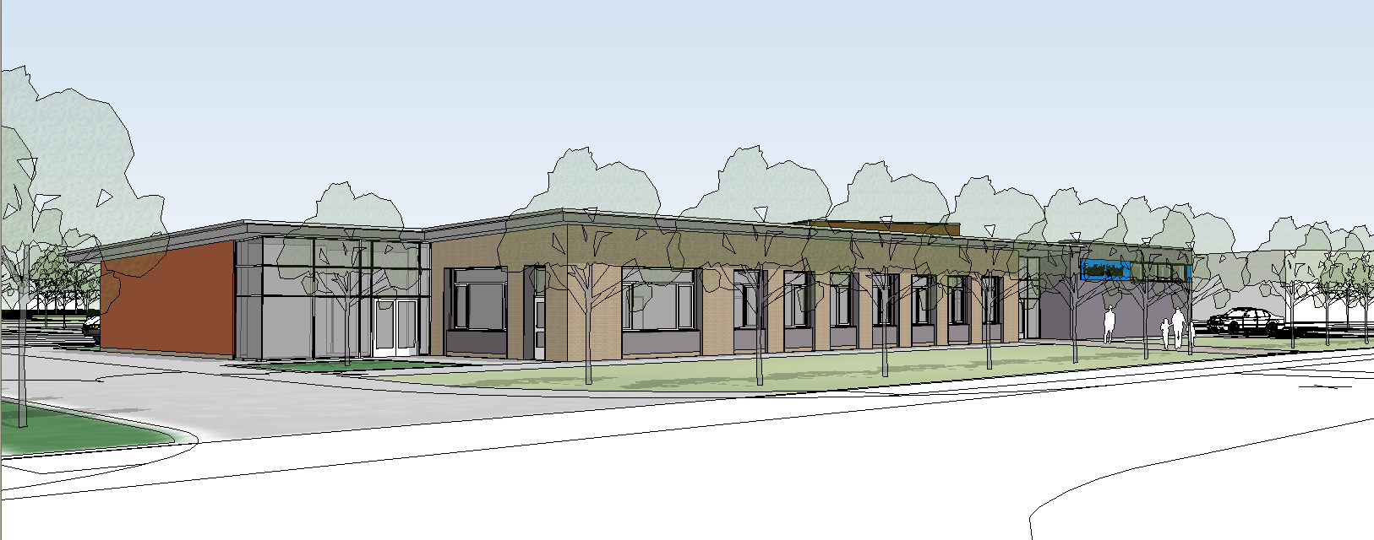
Use of Mobile Phones Document 2020

General use of mobile phones in school.

The use of mobile phones in classrooms is strictly prohibited during school hours. All mobile phones should be switched off or placed on silent, stored with staff coats and bags in the storage cupboard.
Staff wishing to use their phones during the school day must only do this in their break time, in the staffroom or any other non-pupil area. Mobile phones must not be used in the corridors or in classrooms.
In some circumstances staff may have access to their phones during lesson times e.g. family emergency. Staff needing to leave their phones on during lesson times must first seek permission from the head teacher in agreement with the class teacher.

Use of mobile phones in the community.
When out in the community each group must leave a mobile phone contact with school, in case of emergencies or the school needs to contact the group. If staff do not access to a mobile phone the group must take one of the school mobiles and leave the number with the school office and on the Going Out Form. Any staff needing to use their mobile phone while out in the community must do so for school business only and only when safe to do so. Staff needing to use their mobile phones for personal reasons must first seek permission from the Head Teacher in agreement with the class teacher.

Use of mobile phone cameras
Staff are not permitted to use personal mobile phones to record images of pupils, this includes when on field trips, community visits and residentials. However with the express permission of the Headteacher, images can be taken provided they are transferred immediately and solely to the schools’ network and deleted from the staff device. For further details please referrer to the E-Data storage policy.

Staff that divert from this policy without prior approval front Headteacher could face disciplinary action.

