Foxfield School
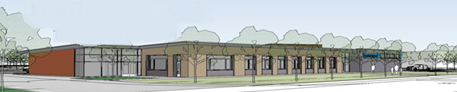
Manual Handing
Policy
(Including the use of Hoists, Handling belts and Vehicle restraints)
Updated 29/01/2020

Senior Member of Staff Responsible: Mr Paul Howley

Contents

- Introduction

- Legal responsibilities

- Equipment
  - Hoists
  - Slings
  - Handling belts
  - Rains
  - Vehicle restraints

- Moving pupils

- Training

- Making Referrals

- Reporting Problems

Introduction
At Foxfield School there will always be a need to move and handle some pupils in order to meet their daily care needs and to give them access to the curriculum.
For staff working with such pupils it is an integral part of the job.
The demands of working in such conditions can lead to problems for both staff and pupils and therefore it is essential that the clear guidelines that are provided and techniques that staff are taught to use are strictly adhered to.

Legal Responsibilities
There are a number of regulations and Health & Safety documents which refer to correct procedures and responsibilities of employers (see Handbook document on Health & Safety). The guidelines and instructions given with moving and handling are recognised by the school as essential to improved and more effective practice with pupils.
It is staff’s responsibility to read and be up to date with Health and Safety guidelines.
Equipment
The range and quality of resources used to facilitate safe manual handling is developing constantly and new equipment has been introduced into the school as part of the new building program.
Staff are given appropriate training by moving and handling consultants and competent staff. Subsequently it is important that good practice is understood, shared and strictly adhered to.

Hoists
The school has 19 ceiling tracking hoists located;
- 6 in the PMLD provision across 3 classes
- 4 in the pool 2 in each pool
- 2 in each key stage wing
- 1 in the sensory room
- 1 in the physiotherapy room
- 1 in the medical room
Hoists are regularly serviced by a contractor and are checked by staff for any anomalies each time they are used.
In addition to the ceiling hoists the school has 3 mobile hoists 2 for external use and 1 for pupils to access the trampolines.
Slings
Dry slings used by pupils are allocated to that particular pupil. (All pupils using a sling must have a Sling Record Document (see appendix 2) competed and attached to their individual manual handing plan). The school has a number of universal slings for emergencies; these slings have been verified by the Authority Occupational Therapist (OT). Wet slings used in the pool are of a universal design and can be used by most pupils once passed as fit for purpose by the OT.

Handling Belts
Handling belts are used in school for supporting in moving and handling only. All pupils using handling belts must have a documented referral from the Authority OT (see making referrals)

N.B. Handling belts must not be used for any sort of restraint or physical control.

Rains
Rains are used in school to support pupils that can demonstrate challenging behaviour. All pupils using rains must have a documented referral from the Authority OT (see making referrals).

Vehicle restraints
Vehicle restraints are used on the school mini bus to support pupils that can demonstrate challenging behaviour on transport. These restrains can only be used by pupils with a documented referral from the authority OT. They can come in the form of a 5 point harness (Crelling 13 or 31), a magnetic vest or a seat belt buckle. All these restraints restrict the pupils ability to leave the seat. In case of an accident the following procedures must be adhered to;
- All pupils that use any form of vehicle restraint must have a documented referral
- All vehicles must carry a seatbelt cutter which can be found in a stated location
- All vehicles must have a visible sign in the window stating that the vehicle restrains are used and the location of the seat belt cutter.
- Seat Belt Buckles; 1986 (Construction and use) Regulation 48 (4) (d) states that;

The buckle or other fastening of the seat belt shall-
- be so maintained that the belt can be readily fastened or unfastened;
- be kept free from any temporary or permanent obstruction;
And
- (iii) except in the case of a disabled person's seat belt, be readily accessible to a person sitting in the seat for which the seat belt is provided;

Due to the challenging nature of some of our pupils the use of a seat belt buckle can be justified on the grounds of risk reduction and that it is in the child’s best interests. The pre-mentioned safety procedures will support in this risk reduction.

Moving Pupils
There is now a range of equipment in school to help with moving pupils e.g. hoists, slings, sliding sheets and handling belts. Guidance on the safe use of this equipment is provided by training consultants and on a more regular basis by the school Occupational Therapist and Physiotherapist. All pupils needing manual handling will have a Manual Handing Plan (see appendix 6) that is reviewed regularly.

Where there is a need to move pupils without equipment it is essential staff take into account:
- Has there been an assessment of the load, individual capability, task and environment? Risk Assessment (see appendix 3.)
- Techniques for handling some pupils will vary according to the pupils needs. e.g. moving a pupil from a wheelchair vis-à-vis moving a pupil with challenging behaviour.
For pupils that can demonstrate challenging behaviour please refer to the school behaviour management policy.

Making referrals
For any equipment that is needed a referral to the Authority OT must be made (see appendix 5).

Reporting problems
Any problems identified with any of the hoists or vehicle restraints used in school must be reported at the earliest opportunity to the Deputy Headteacher. Problems with slings or handling belts must be reported to the Authority OT at the earliest opportunity via a referral form followed by a phone call.

Finally, although it is the school’s aim to continue to improve and develop the use of moving and handling equipment to meet the needs of our pupils, it is important we recognise the limitations of some equipment and our own limitations; and that the daily moving and handling of our pupils will require constant thought and risk assessment to determine appropriate techniques and/or equipment for safe practice.

Appendix 1
For information about hoists – see Foxfield Maintenance files
Appendix 2
For information about slings and harnesses – See sling record (Example provided)

Appendix 3
For more information about risk assessments regarding the moving and handling of pupils see below

Pupil Name: |  |  |  |  |  | DOB: 15/07/96 |  |  | DATE:30/10/12
Assessed by (Print): |  |  |  |  |  |  | Signature
Task | No. Of Staff | Equipment and handling method |  |  | Special Instructions  Clearly explain your actions & promote the individuals’ independence
Transfers:

Toileting:
Chair to bed

Other

Bath or Shower

Mobility:
Chair to Walker (reverse)

Sit to Stand (reverse)

In/Out of Vehicles
 |  |  | MANUAL HANDLING OPERATIONS RISK ASSESSMENT GUIDELINES

WEIGHT
Each box in the diagram below shows guideline weights for lifting and lowering. Operations within the guidelines can be considered as low risk, those up to twice the guideline weights are likely to be medium risk and any operations more than twice the guideline weights should be rigorously assessed – Even for fit, well trained individuals, working under favourable conditions.

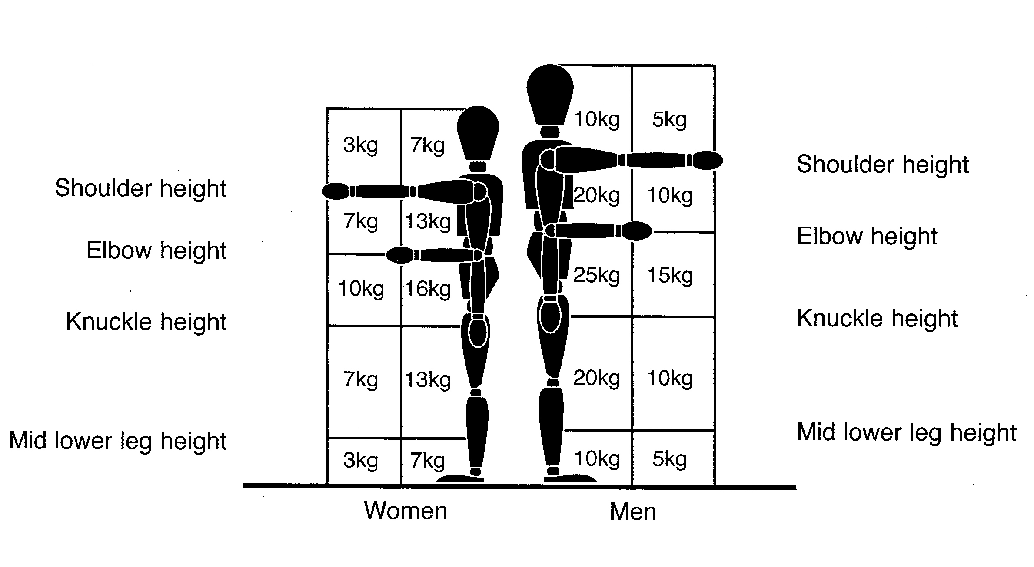
The weights assume that the load is readily grasped with both hands and that the operation takes place in reasonable working conditions with the handler in a stable body position. If the handlers hands enter more than one box during the operation use the smallest weight. Use an in-between weight if the hands are close to a boundary between boxes. If the operation must take place with the hands beyond the boxes, make a more detailed assessment.

CARRYING

Similar guideline figures apply to carrying operations where the load is held against the body and is carried no further than about 10m without resting. If the load is carried over a longer distance or the hands are below knuckle height, a more detailed assessment should be made.

TWISTING  Reduce the guideline weight if the handler twists to the side during the operation. As a rough guide reduce by,  - 10% if the handler twists beyond 45’ and  - 20% if the handler twists beyond 90’. |  |  |  | FREQUENCY  The guideline weights are for infrequent operations (up to about 30 operations per hour).  As a rough guide reduce the weights by,  - 30% if the operation is repeated 1-2 times per minute; and by  - 50% for operations between 5-8 times per minute; and by  - 80% where the operation is repeated more than 12 times per minute.

