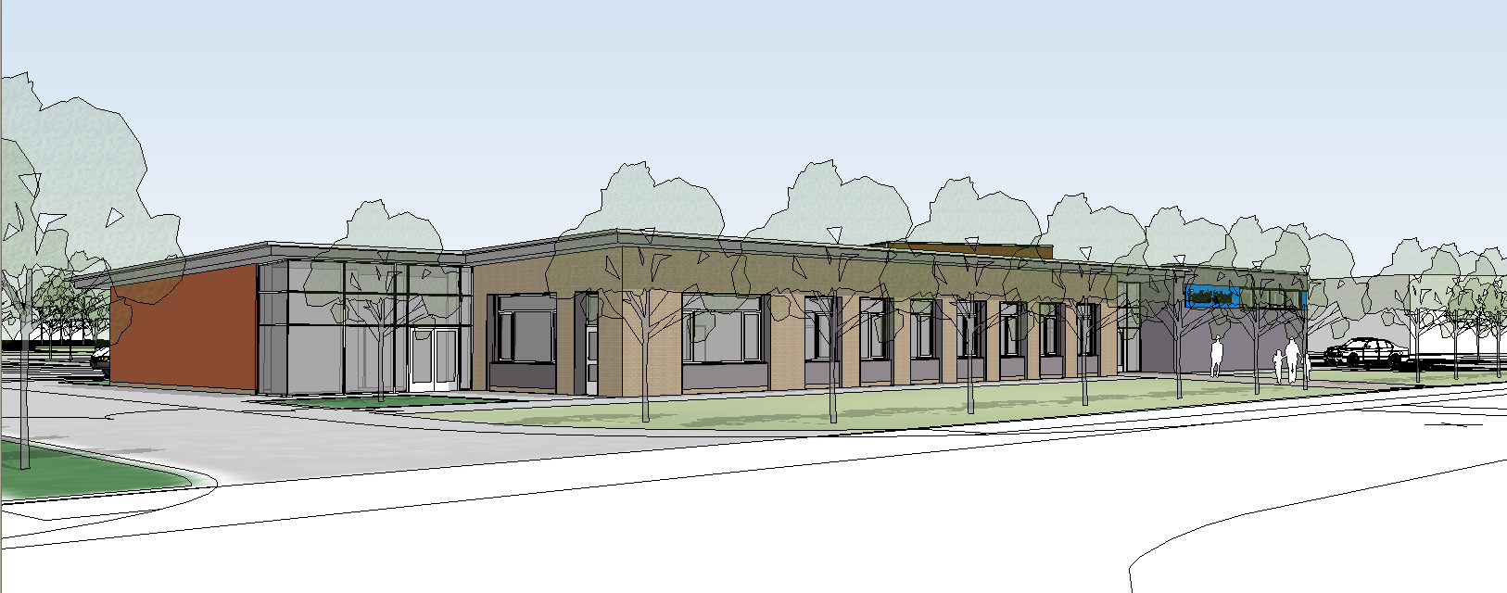

What is asthma?
Asthma is a common condition that affects approximately one in seven children. However, there is nothing to stop the majority of children with asthma leading full and active lives and pupils should be encouraged to participate in all school activities.

Asthma affects the airways in the lungs. Symptoms include cough, wheeze, tight chest and breathlessness. Children with asthma have airways that are over sensitive which causes them to become red and inflamed very easily. When exposed to irritants called “triggers”, the inflammation gets worse and the airways tighten.

What is a trigger?
There are many triggers that can irritate the airways and make a child’s asthma worse. Common triggers include colds,
viral infections, exercise, laughter/upset, house dust mites, tobacco smoke,
chemicals, and changes in the weather, air pollution and pollen.

It is important for teachers to be

Asthma Policy 2020

aware of triggers in the school environment and that exposure to them may make it difficult for the child with
asthma. Avoidance of these factors is advisable wherever possible, and guidance
should be sought from the school nurse.

Asthma Treatment
Asthma is generally treated with inhalers. There are two main groups of treatment.

Preventers: These are generally coloured BROWN or ORANGE.

Preventer inhalers are normally given twice a day to prevent asthma attacks by making the airways less sensitive. They do not work straight away and will not stop an attack that has started.

Common preventers are Becotide, Flixotide and Pulmicort.

Relievers: These are generally coloured BLUE.

Reliever (blue) inhalers open up the airways when they have tightened in an asthma attack and work very quickly; within 5-10 minutes. They relieve the symptoms of cough, wheeze, tight chest and breathlessness.

Common reliever inhalers are Salbutamol (Ventalin) and Bricanyl.

Asthma Education
The school has a responsibility to advise all staff (class teachers, sports teachers, break time supervisors) on practical asthma management. The school nursing service can play an important role here and their involvement is encouraged.

Who has the inhaler at school?
At school the issue of access to the inhaler is important.

IT IS ESSENTIAL THAT THE PUPIL HAS IMMEDIATE ACCESS TO THEIR RELIEVER (BLUE) INHALER AT ALL TIMES.

It is recommended that wherever possible all children should carry their own reliever (blue) inhaler or it should be kept in the classroom with them.
Delay in giving treatment can lead to an attack becoming more severe and, in rare cases, could prove fatal.

Sports
The P.E. teacher has an important role to ensure good asthma management in P.E. lessons. The school has a role to ensure that the P.E. teacher knows which pupils have asthma. Whilst exercise is a potential trigger, participation in sport is strongly encouraged. To enable pupils to participate, the P.E. teachers should be aware that a number of pupils with asthma will take a dose of their reliever (blue) inhaler before exercise. This helps to prevent exercise induced asthma. If a pupil becomes wheezy or breathless, a further dose of the reliever (blue) inhaler should be given. Pupils who are normally active should not be forced to participate in sport if they say they are too wheezy to continue.

P.E. teachers must ensure that a pupils reliever (blue) inhaler is taken to the sports field or swimming pools.

Pupils who are noted to need their reliever (blue) inhaler frequently may have poorly controlled asthma. This should be discussed with the school nurse as they may need to see their own doctor for review of their current treatment.

Passive Smoking
Both staff and pupils should understand that inhaling someone else’s smoke can trigger an asthma attack. The school’s policy on smoking should ensure that pupil’s are not exposed to this hazard.

Nebulisers
Nebulisers are electric devices that deliver asthma treatment in the form of a mist. Due to developments in asthma devices and treatment, nebulisers are now rarely indicated in treating children’s asthma. In the event of a child using a nebuliser, the school must liaise closely with the G.P./Hospital Consultant or nurse on correct and safe management.

How to help a child during an attack
Most children will learn from past experience and know what to do in an asthma attack and they should be carrying appropriate emergency treatment (the reliever {blue} inhaler).

Asthma attacks can be distressing and frightening for all involved, so the number one rule is:

- STAY CALM and reassure the child.
- Let the child use their reliever (blue) inhaler.
- Help the child to breathe. Encourage them to relax and breathe slowly and deeply. Loosen any tight clothing around the neck.

DO NOT

- hold the child down.

- put the child by an open window. It is natural to want to place a child who is having difficulty breathing somewhere they can get plenty of air but this can make the attack worse.

- Cuddle the child. This can feel restrictive. Give the child space.

- Wait 5 – 10 minutes. If the child is fully recovered, they can return to normal activities.
- If the asthma has improved but not fully recovered, they can be given a further dose of the reliever (blue) inhaler.

After the attack
Parents should be informed about the attack.

Getting help in an emergency
A child is having a severe asthma attack if:

- The child is distressed and is having difficulty in speaking full sentences due to breathlessness.
- The child is breathless and getting exhausted.
- The reliever (blue) inhaler has not helped.
- The child’s lips turn blue.

CALL 999 FOR AN AMBULANCE
Give one puff of the reliever (blue) inhaler every 30 seconds up to a maximum of ten until help arrives.

CARE PLANS

If staff have pupils who are asthmatic please make sure you have an easily accessible care plan to hand.

Allergies

It is important that all staff are made aware of any allergies pupils may have.
It is the responsibility of the class teacher to make a note of allergies in the teacher record file along with any other necessary information relating to the allergy. Support staff should pass on this information to all staff who may teach, or have contact with that pupil, including supply staff.
ASTHMA MANAGEMENT PLAN

How to recognise a pupil’s asthma is getting worse;

- Increased cough
- Increased wheeze
- Increased breathlessness
- or if the pupils is needing to use the RELIEVER (blue inhaler) more than 2 puffs every 4 hours

What to DO

Give 2 puffs of RELIEVER (blue inhaler)
Wait 5 minutes. If no improvement, repeat.
Wait a further 5 minutes. If no improvement give 1 puff of the RELIEVER (blue inhaler) every 30 seconds up to 10 doses.
Seek medical advice urgently.

MEDICAL ALERT/EMERGENCY

It is a medical alert/emergency if the pupil is:

- Breathing faster than usual
- Using their tummy muscles to breathe
- Having difficulty speaking (due to their asthma symptoms)
- Having difficulty in walking (due to their asthma symptoms)
- Pale or blue around the lips

What to DO
DIAL 999 – YOU MUST SEEK MEDICAL HELP
Give 1 puff of the RELIEVER (blue inhaler) every 30 seconds up to 10 doses using a spacer device

This care plan is applicable to all asthma sufferers.

In school, summons the school nurse but do not wait for her to arrive, if the pupils presents with any of these symptoms give then their inhaler as indicated.

When out in the community, follow care plan, but if in doubt, ring 999.

