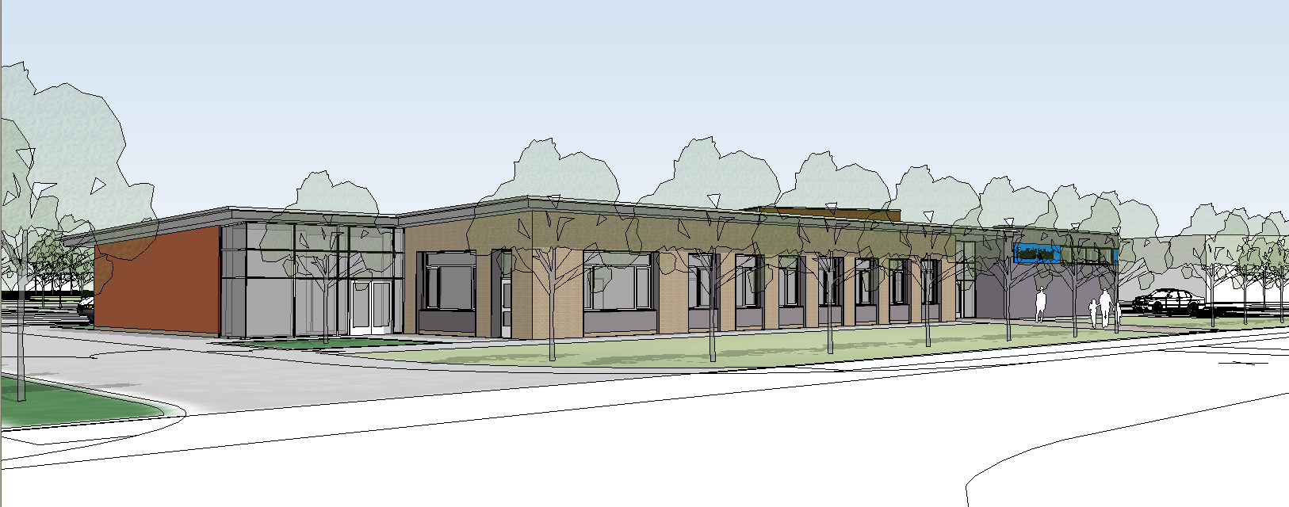

At Foxfield we wish to include everyone, staff, pupils, pupils, parents, governors and the wider community in providing a caring, stimulating environment which enables everyone to feel valued and achieve their full potential.

We can achieve this if:

- there is a shared commitment by pupils and parents and the school
- a high quality education is provided
as the right of every child
- effective learning is achieved by positive discipline

We ask you to share with us a commitment to a quality experience for your child through our Home – School Agreement.

Pupil and Parent Expectation of our School

The school will:

- provide a safe, well ordered and caring environment where learning can take place
- provide a place where each pupil is valued as an individual
- provide and maintain a happy and enjoyable school ethos
- provide access to broad and balanced curriculum

Home-School Agreement
2020

- provide a range of opportunities and challenges to enable pupils to achieve their full potential
- provide regular information about progress and performance
provide opportunities to express views on wider school issues
- provide work of a suitable standard for each child to that they can engage with the work and be challenged by it
- provide opportunities for parents to discuss their child’s progress, conduct and achievements and to provide an annual written report
- listen to any parental concerns and we will act upon them

The School’s Expectations of Parents and Pupils

We expect you to:

- ensure regular and punctual attendance
- notify school on the first day of absence
- not have holidays in term time
- encourage effort and achievement
- encourage completion of homework and return it to school (where applicable)
- support the school Code of Conduct and guidance necessary to ensure smooth running of the school
- participate in discussions concerning progress and attainment

Therefore Foxfield School sends each parent a copy of its Home – School agreement in the induction pack sent out to parents of pupils entering year 7. This state’s exactly what the school aims to do for parents and pupils and what it expects parents and carers to do in support of the school. Parents/Carers and the Headteacher will sign this at the beginning of the academic year. A copy of this agreement can be seen in appendix 1.

FOXFIELD SCHOOL
HOME SCHOOL AGREEMENT
-Revised 2014

The School provides parents and carers with a copy of the prospectus when they first visit the school. As and when the prospectus is updated parents and carers are invited to have a new copy. The latest prospectus is also available on the school website at www.foxfieldschool.co.uk.
This contains information about:

- the aims and ethos of the school

the organisation and contents of the curriculum

- the way in which the school will address any concerns about pupil behaviour, attendance or child protection.

- the school homework policy

- the information the school will give to parents and carers

- the parental partnership policy in school

The School will:

- deliver all aspects of it’s provision outlined in the prospectus

- inform parents of any major changes to the school from those outlined within the prospectus

Parents and Carers will:

- support the work of the school as far as possible

- inform the school of any problems or concerns that might impact upon their child’s work, behaviour or attendance.

- try to attend all parents meetings and discussions about their child’s progress

Signed : …………………………………………………… (Parent/Carer)

Signed : …………………………………………………… (Headteacher)

Initial Equality Impact Assessment

Policy Title | The aim(s) of this policy | Existing policy (✓) | New/Proposed Policy (✓) | Updated Policy (✓)
 |  |  | ✓

This policy affects or is likely to affect the following members of the school community (✓) | Pupils | School Personnel | Parents/carers | Governors | School Volunteers | School Visitors | Wider School Community

Question | Equality Groups |  |  |  |  |  |  |  |  |  |  |  |  |  |  |  |  |  |  |  |  |  |  |  | Conclusion
Does or could this policy have a negative impact on any of the following? | Age |  |  | Disability |  |  | Gender |  |  | Gender identity |  |  | Pregnancy or maternity |  |  | Race |  |  | Religion or belief |  |  | Sexual orientation |  |  | Undertake a full EIA if the answer is ‘yes’ or ‘not sure’
 | Y | N | NS | Y | N | NS | Y | N | NS | Y | N | NS | Y | N | NS | Y | N | NS | Y | N | NS | Y | N | NS | Yes | No
 |  | ✓ |  |  | ✓ |  |  | ✓ |  |  | ✓ |  |  | ✓ |  |  | ✓ |  |  | ✓ |  |  | ✓ |  |  | ✓
Does or could this policy help promote equality for any of the following? | Age |  |  | Disability |  |  | Gender |  |  | Gender identity |  |  | Pregnancy or maternity |  |  | Race |  |  | Religion or belief |  |  | Sexual orientation |  |  | Undertake a full EIA if the answer is ‘no’ or ‘not sure’
 | Y | N | NS | Y | N | NS | Y | N | NS | Y | N | NS | Y | N | NS | Y | N | NS | Y | N | NS | Y | N | NS | Yes | No
 | ✓ |  |  | ✓ |  |  | ✓ |  |  | ✓ |  |  | ✓ |  |  | ✓ |  |  | ✓ |  |  | ✓ |  |  |  | ✓
Does data collected from the equality groups have a positive impact on this policy? | Age |  |  | Disability |  |  | Gender |  |  | Gender identity |  |  | Pregnancy or maternity |  |  | Race |  |  | Religion or belief |  |  | Sexual orientation |  |  | Undertake a full EIA if the answer is ‘no’ or ‘not sure’
 | Y | N | NS | Y | N | NS | Y | N | NS | Y | N | NS | Y | N | NS | Y | N | NS | Y | N | NS | Y | N | NS | Yes | No
 | ✓ |  |  | ✓ |  |  | ✓ |  |  | ✓ |  |  | ✓ |  |  | ✓ |  |  | ✓ |  |  | ✓ |  |  |  | ✓

Conclusion | We have come to the conclusion that after undertaking an initial equality impact assessment that a full assessment is not required.

Preliminary EIA completed by | Date | Preliminary EIA approved by | Date

