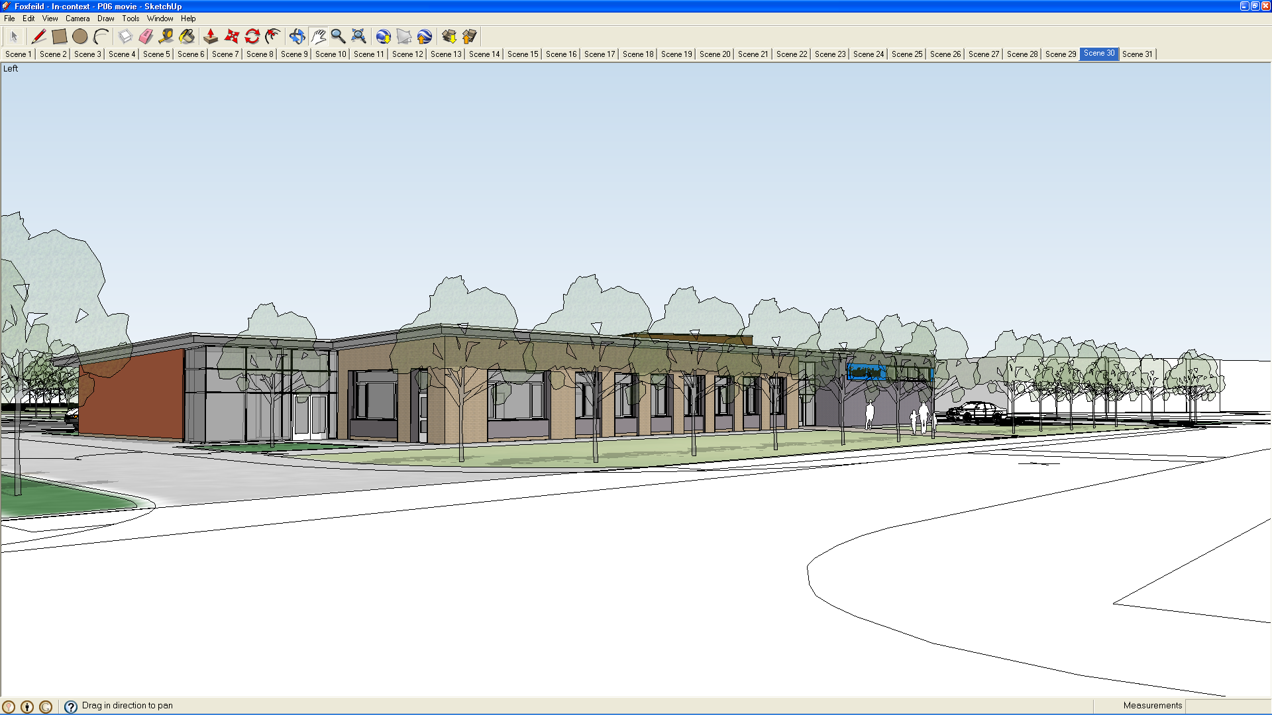
Under the Occupiers Liability Act and the Health and Safety at Work. Act it is the responsibility of the school to ensure the safety of all pupils arriving and departing from school premises at the beginning and end of the day. This includes a duty to ensure the appropriate care and supervision of the pupils up to the point when the transport vehicles leave the school grounds.

This policy is therefore intended to ensure that:

- The safety of the pupils is the overriding priority.

- That all of the school staff, escorts and drivers are aware of the procedures to be followed.

- That the arrival and departure of pupils is well managed and operates as smoothly and efficiently as possible

To ensure that these factors are addressed the following procedures are to be strictly implemented by all of the people involved. Any deviation from these procedures must only be done with the prior agreement of the Head teacher. Those that divert from this policy without prior approval from the Head teacher could face disciplinary action.

School Transport Policy
2020

Arrival at school

The vehicles will arrive between 08.35 and 08.45. Each vehicle will park in a designated bay (see appendix 1). The pupil entrance gate will automatically open between the hours of 08:30 and 09.30

The pupils will disembark from their vehicles under the supervision of the escort and will be escorted into the building through the pupil entrance door.

Pupils and Escorts should walk at all times along the rear of the parking bays on the paved area (not on the grass or flower beds) and on the right hand side of the corridors when in the school building.

The level of assistance required by individual pupils will vary. Escorts should ensure that the pupils are adequately supervised, and if they require additional support they should speak to the Head teacher who will arrange for a member of the classroom staff to meet their vehicle on the yard each morning and provide assistance.

The pupil entrance door will not be opened until the bell chimes sound at 08.45 and so pupils who arrive early should remain on their buses or can wait on the seated area outside the pupil entrance, weather permitting.

Upon entering the school all pupils should go straight to their classrooms
where at least one member of staff will be ready to receive them.

Once pupils have disembarked from their bus and escorts have safely handed over pupils to the care of the school staff buses can leave via the automatic gate exit (see appendix 1)

Departure from school

School playground gates are timed to open automatically for vehicles from 14:45 up until 15.30. During this time a caretaker will monitor the pupil loading area. Minibuses will line up in bays 1 to 20 with the engine switched off and the keys out of the ignition.

Pupils should be dismissed from their classes no earlier than 15:05, except for wheelchair users who can be escorted to their buses at 15:00 as it takes some time to get them safely boarded and ready for their journey.

Some pupils involved in independence training can be dismissed from class and are able to make their own way to their buses; others will be taken to the school hall where their escorts will be waiting for them. Each pupil will be

- Responsible for finding their own bus once in the playground.
- Staff and pupils should walk at all times along the rear of the parking bays using the paved area provided (avoiding walking over the grass or through the flower beds).

In order to ensure that the loading and departure of the vehicles runs safely
and smoothly one of the caretakers will act as a yard duty attendant and will oversee the departure of the vehicles from the playground each morning and afternoon.

It should be noted however that any issues that need to be raised about the departure or arrival of the pupil transport should be discussed with the Head or Deputy.

At the end of the day vehicle engines must remain off until all drivers have indicated with a clear and agreed sign that all pupils are present and are safely seated and that the bus is ready to depart.

Only when all drivers have indicated that they are ready to depart will the caretaker then give the go ahead to switch on engines and let the buses move off in an orderly fashion in the Bay Number order (1 to 23).

A race to get out of the gates first is not acceptable. Any deviation from this will be reported and may lead to disciplinary action.

For health and safety reasons buses arriving after 15:00 must remain outside the premises until signalled to enter the pupil loading area. This is due to the fact that at this time pupils may be exiting the school building and walking in the loading areas.

The afternoon’s caretaker will supervise the gates and the pupil loading area.

This policy and its implementation will be reviewed regularly to ensure that the procedures are being followed and
that the system still remains best practice. Any comments, concerns or
suggestions about this policy should be directed to the Head teacher or Deputy.

Taxis
There are a number of Taxi’s that visit the school in order to transport individual pupils. These vehicles must use the three bays after the last bus bay i.e. Numbers 21 to 23. We acknowledged that the taxi’s only carry one or two pupils and may be ready to leave long before the buses. However, on the grounds of health and safety and our commitment and responsibility to safeguard all our pupils we cannot allow vehicles to move off through the play ground until all pupils are safely aboard their vehicles and out of danger. This is not the case in the mornings as vehicles arrive and depart at different times and the risk to the pupils is not as high as they are walking away from vehicles and into school.

Parents
Parents who wish to bring their son’s/daughter’s to school and/or pick up from school via the main pupil entrance will need to enter the playground and park in a vacant taxi bay 21, 22 or 23. Again if picking up in the afternoon parents will need to wait until the ‘All Clear’ is given.

Please Note:
All vehicles please note that the speed limit when entering the school grounds

is 5mph. We expect all users to strictly comply with this speed limit as these are areas where pupils could be present or may run out in front of vehicles if they have managed to evade their supervisors.

We all need to be able to guarantee the safety of the children under our care and therefore if there are persistent speed offenders will be spoken to and appropriate action taken.

Thank you for your cooperation.

PDH 09/15
Updated 09/18

Pupil Entrance

PMLD wing
PUPIL GATE
Pupil Playground

19 to 23
Substation

Key Stage 4 Wing
Grassed verge Area
7
6
8
9
10
11
12
13
14
15
16
2
1
17
18
5
4
3

Key Stage 3 Wing

Paved area

