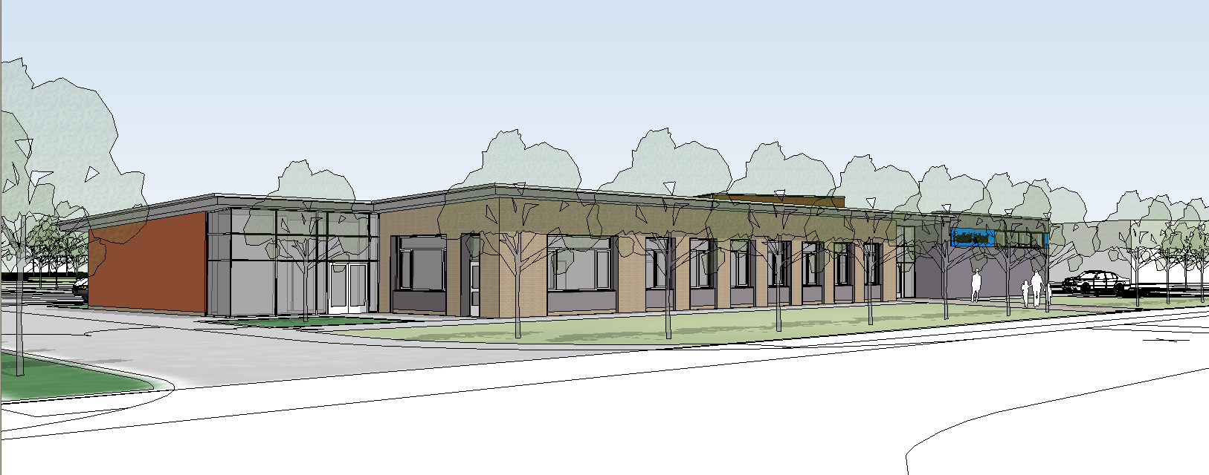
Visitors Policy
2020

Introduction

This document is intended to give informative and friendly advice to all those who enter and use Foxfield School. The protocol is also intended to ensure that everyone knows the procedures, class lessons are not interrupted, pupil’s safety is guaranteed and that our relationships with the neighbouring community is not compromised by parking access to their homes being restricted.

General Overview

Signing in and out
All visitors must report to the reception. They will then be asked to sign in using our electronic ‘Inventory System’ giving their details, including their car registration numbers. At this time they will also need to read the fire regulations and be made aware of lockdown procedures. Additionally they will need to state the purpose of their visit and with whom they are meeting. The Inventory system will then take their picture which they must stick on the outside of their clothing where it can be seen.

If their car is not in a car park, they will be requested to move it to a car park before being issued with a visitor’s badge.

Visiting Supply Staff
If a visitor is coming into school to work on supply, they will need to show identification and have a current DBS for us to check against their records. If the supply visitor had been to the school before and we have them on our records the DBS form will not be necessary.

Once they have their badges they will then be issued with a swipe card to open doors, which they must return to the swipe card box at the front of the office in the afternoon before leaving the premises.

Lone Workers Policy

Single visitors and work persons should be made aware of and have made arrangements to comply with the ‘Lone Workers’ policy adopted by Foxfield School, they will need to sign an agreement to this. Workmen arriving during school hours will be escorted at all times around the site unless they are able to provide a current DBS certificate.

Visiting professionals

Other professionals who visit the school on a regular basis such as therapists will have their own local authority badges so sign into the visiting professionals area of the system. This does not take their photograph as it assumes that the visitors already have DBS records on file and that they will have their own identification badges with them.

Visitors on courses

Any person coming to Foxfield for a course such as Team Teach will already hold a current DBS as they will be from another Wirral School.

If we have prior knowledge of those names attending the course we will programme their names in beforehand in order that they can sign in far more quickly on the days of the course.

Visitors without badges (known as well as unknown)

Any visitor not wearing a badge will be challenged by staff. Staff not challenging unidentified visitors will be neglecting their duty to ensure school security and pupil safety. Remember that infrequent visitors, even parents, volunteers etc. will not be known by all staff and therefore need to be wearing a badge.

If you see a visitor who is known to you but is not wearing a badge, the chances are that they have not followed the correct visitor’s procedures (see above) and so it is your duty to politely remind them of our protocol and request that they return to the office to obtain a badge.

No occasional visitor should be issued with, or loaned a door lock swipe card by any member of staff, other than the receptionists who will make a note of the number.
Workmen coming onto site should be asked about their requirements for door access etc. – if constant access is needed they will have to come to an agreement with the management. A door monitor from one of the senior classes may be identified to help in these situations if this is possible. If
this is not possible then the workmen will have to be inconvenienced. (The need for school security and the welfare of pupils outweighs time and inconvenience to site workmen).

Parents visitors

All parents must follow the visitor’s procedure and obtain visitors badges at all times no matter how well they think they are known to staff. This will also be the case even if they have pre – arranged meetings with teachers and other professionals. They must abide by all procedures as they will not be known by everyone on site and will therefore be challenged by Foxfield personnel if they are not wearing badges (as part of our responsibility and duty of care to the pupil’s).

Parent dropping pupils off in the foyer in the morning, or picking up in the afternoon or dropping off after an appointment do not need to sign in as they will not be progressing into the main body of the school. However, they must wait in the foyer for a member of the classroom staff to come and collect their child. They must not – leave their child without seeing the secretary or someone in authority and ensuring that their child has been handed over into the safety and jurisdiction of a member of the school staff.

Polite Note

Parents must always follow the signing in procedures. Parents and carers must not walk through the building without identification or enter classes during lesson times without prior arrangement, as this could be detrimental to the balance of lessons and the concentration of pupil’s and staff alike.

If parents wish to discuss issues with staff they can do so via chat books and letters, or request that staff phone them. Staff are also happy to meet parents and carers after school. Discussion cannot take place in class
in front of pupil’s or during lesson time.

Independent Travel Project

All pupils arrive on pre arranged transport arranged by the authority transport apart from those pupil’s who are part of our independent living skills programme covered by the ‘Independent Travel Project’. These pupils and their parents or carers have entered into a contract allowing their children to travel on public transport, independently to and from school. In these cases there are strict guidelines to follow, part of which means that they are able to use mobile phones and keep in constant contact with school and their parents if in difficulty. Parents or carers have also signed an agreement to enable their sons or daughters to travel under the Foxfield guidelines on an independent basis. Parent’s who
have not undertaken this agreement with the school and authority transport, and whose children are not part of the ‘Independent Travel Project’ should, not under any circumstances send
their children into school unaccompanied.

Parents as volunteers

Parents who are assisting in school as volunteers must follow the signing in process but on receipt of their visitors pass may then proceed to the class in which they will be working, which will have been organised by a senior member of staff by prior arrangement.

After school hours

Foxfield School has frequent visitors after the official school day i.e. 3.05pm. Workmen will generally ask for the assistance of the caretaker and it is the responsibility of the member of staff or caretaker to ask these visitors to follow the protocol above as staff and pupils may still be on site due to after schools clubs and extended schools projects.

Therefore it is important that ALL staff are knowledgeable about the Visitors and Lone Workers policies
and where badges are kept, questions to ask etc.

There are also a number of community users which utilise Foxfield School’s facilities and these ‘User Groups’ also need to follow the protocol. The leaders of these groups need to make sure that the caretaker is aware that they are on site and that they are able to contact him if necessary.

