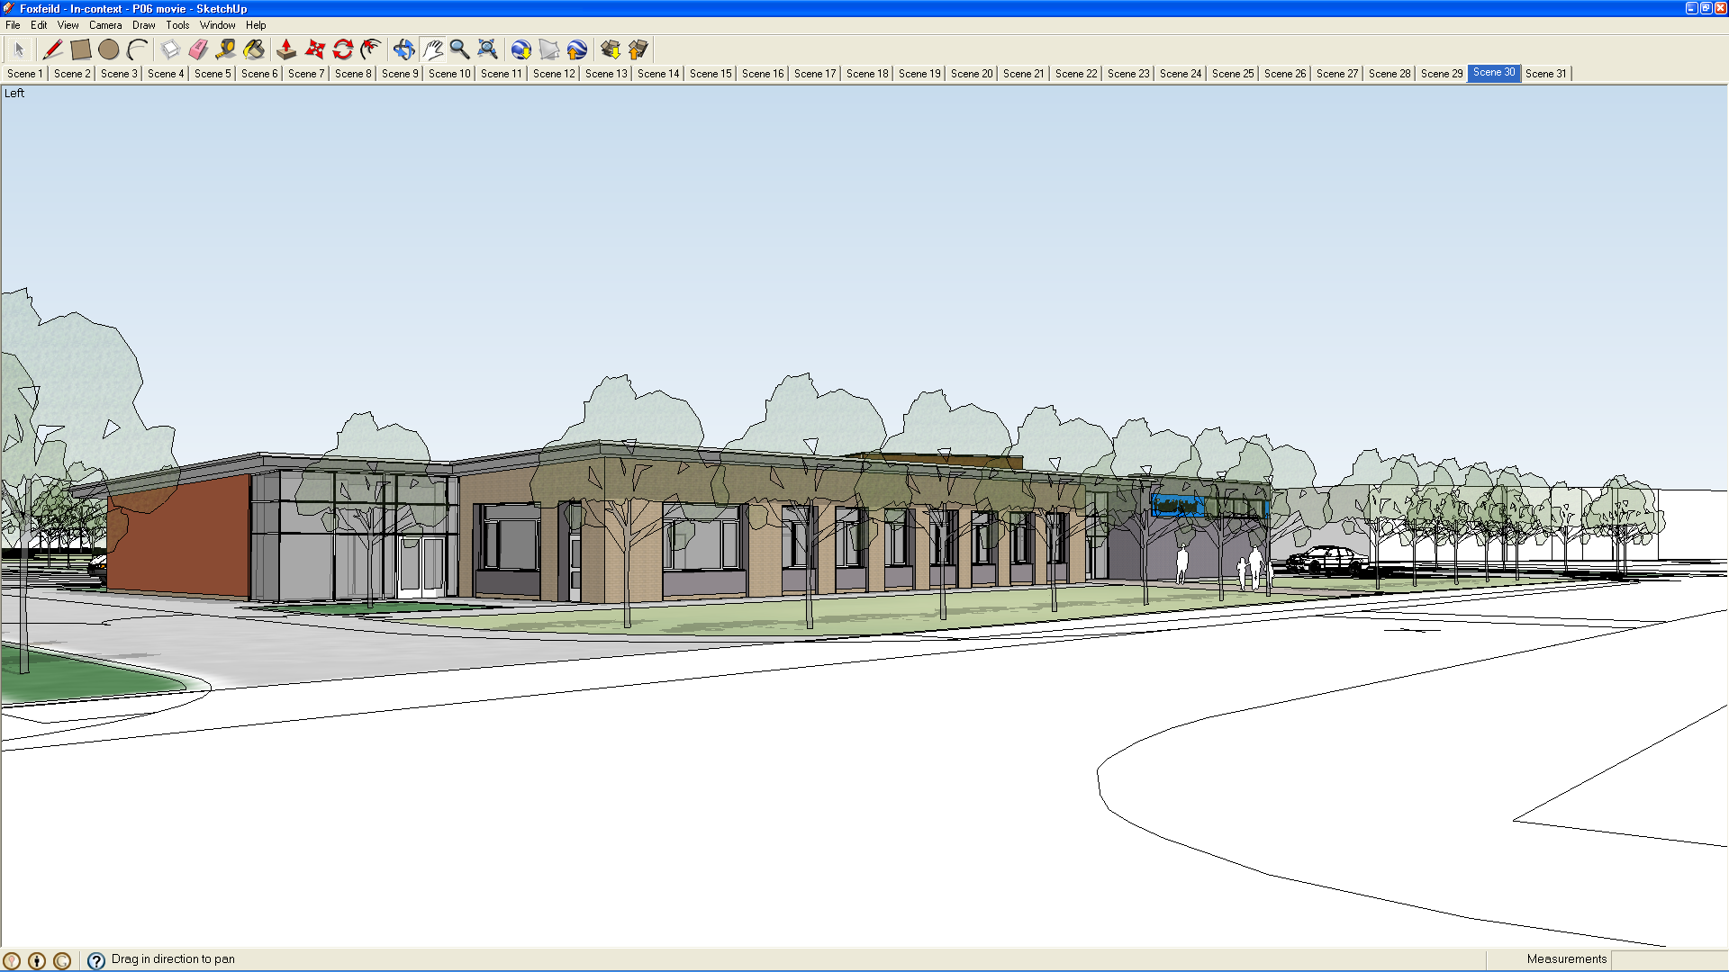
Income Procedure
2020

The school mainly obtains income from:

- The collection of Dinner and Milk money
- Students & Parents, mainly for trips, residentials, fund raising, extended schools and activities (school fund or budget income)
- Public, mainly for lettings (budget income) – see Lettings Procedure
- Third parties, supply insurance, mentoring, PTA, school fund and DFE (budget income)
- Money is stored in a school safe in a room which is locked overnight. Dinner and Milk money is collected on a Friday by G4 security.
NB
Money for uniforms are now paid directly to suppliers and class trip money is stored in a separate safe from the main safe.

Dinner money and Staff/visitor meals money

- Staff and visitors meal money is collected by the school cook and records are kept by her.
- Staff meal money is stored in a locked strong box and kept in a locked room. At the end of the week it is handed into the Finance Clerk with a record of the weekly takings. This is then stored in the safe which is in turn collected by G4 security on a Friday. These monies are allocated to their individual codes and a paying in slip is filled in and submitted via weekly E – returns.
- The kitchen staff are responsible for filling in pupil meal reports which the school cook totals up at the end of the week and passes on to the Finance Clerk

Pupil meals and milk money

- Pupil meals and milk money is sent to the office in a number of ways. Firstly via the pupils’ bus escorts who bring the money to the office in the mornings, secondly by school staff or thirdly by the pupils themselves. The money is then counted by the finance clerk and is allocated against each pupil’s records. A paying in slip is then filled in and the money is bagged and stored in the safe ready for pick up by security on a Friday. Records are kept separately in a locked cabinet. Weekly E – returns are entered and submitted by the Finance Clerk and the records are checked by the Head teacher.
- If a payment for meals has not been made for a particular

- pupil then reports are cross checked with attendance. If a pupils is found to have been in attendance and has not paid then a bill is issued by the Finance Clerk to the parent/carer to request the outstanding amount.

Receipt of Cheques

- All cheques should be made payable to Wirral Borough Council (for income to Budget or to the school for income to Voluntary Funds)
- Cheques should be crossed ‘A/C Payee’
- Cheques should be within date
- For personal cheques the Cheque Card number should be recorded where possible
- A receipt should be issued if requested
- No personal cheques should be cashed either through school budget or voluntary funds
- Any incomplete cheques should be returned to drawer for completion, prior to banking
- Please Note that receipts are issued for any income using the Wirral Receipt Book but are not issued for dinner or milk money, residential holidays, the summer play scheme or after school clubs, unless requested.

School Fund
- Money is sent into the school via the escorts from parents or via staff if though sponsorship, donations etc.
- When income comes in it is given to the Finance Clerk who will record the income and issue receipt where necessary (See previous note).
- Foxfield School has four accounts which are as follows;

- School Fund, (which includes the summer play scheme)
- Residential Holidays,
- Extended Schools Clubs
- Parent Teachers Association (Friends of Foxfield)

- Each of these accounts has a record sheet for recording income and expenses for each activity.
- The money for each account is counted and allocated by the Finance Clerk and all record files are kept in a locked cabinet. The money is then kept separately and is kept in a locked safe which is kept in a separate room off the office which is locked overnight.
- Each of the records is checked against statements by the Finance Clerk and then checked by the Head teacher
- Money is banked at regular intervals but on different days so that no noticeable order is apparent
- All records are authorized and checked by the Head teacher.

- A second secured and padlocked cabinet exists for classes to keep their own class money in for trips out into the community and for drinks and snacks. Each class teacher or Teaching Assistant is responsible for keeping their own records and each classes money is kept in a lockable strong box within this secured cabinet.
- Spoiled receipts and paying in slips are marked ‘cancelled’ and include a brief explanation. These should be signed & dated by a person other than the person issuing the receipt and kept in sequential order.

Budget Income
- Money received in school office via pupil/parent and/ or staff (as described above)
- Money that comes into school is recorded and a receipt is issued (where necessary), using the Wirral Receipt Book
- Spoiled receipts and paying in slips are marked ‘cancelled’ and include a brief explanation. These are signed & dated by a person other than the person issuing the receipt and kept in sequential order.
- All money is counted and a paying in slip is prepared by the Finance Clerk and put into the correct ledger code. This record is kept in a locked cabinet separate from the money which in turn is kept in a locked safe in a separate room off the office which is locked over night.
- The amount of money placed in the safe is then recorded kept in a locked cabinet with the ledger codes.
- An E – return is submitted on a weekly basis along with dinner money income and all transactions are authorized by the Head teacher
- The school pays for a Service Level Agreement from Wirral Authority to supply a Bursar for us so that all income is reconciled against the tabs on a monthly basis.

Income from Hire of Premises
- Money from the hire of premises facilities has a separate code and is dealt with by the Finance Clerk. Again it is stored in the school safe and is collected on a Friday by G4 security along with the dinner and Milk money. (See Hire and Lettings Policy)

Banking of Cash & Cheques
- The Finance Clerk takes the money to the bank on a regular basis but not on the same day

Debt Recovery
- See Debt Recovery Policy Document and Procedures
Taken to Finance Meeting dated ……………………………………Approval at full Governing Body meeting dated ……………………………………Signed (Chair of Governors)
.................................................

