Admissions Policy – Community (LA Maintained Schools)
2020
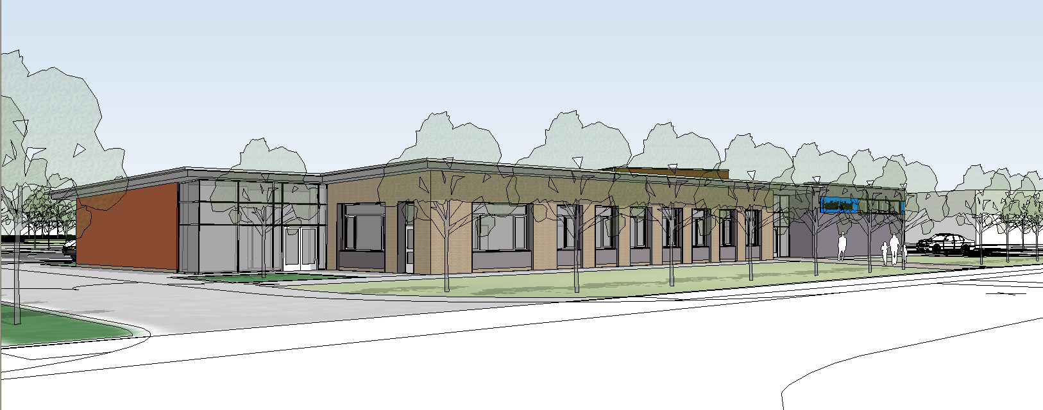

The role of Foxfield School

Foxfield School welcomes applications from all parents and carers in the Wirral Area having children with Complex Learning Difficulties. It is one of two schools in the area that is able to accommodate and educate such children and parents make their own choice of schools after visiting each one and meeting with the Head Teacher and looking around the building.

The role of the Local Authority

As a Community Special School funded by the Local Authority however, Foxfield does not control its admissions. It is the Local Authority that controls admissions to the school in accordance with its Special Educational Needs and Disabilities (SEND) policies and procedures as well as taking into account the 2014 Code of practice and the 2010 Equality Act.

The role of parents

Parents are encouraged to visit and learn about the schools that are appropriate to meet their child’s needs. They do not have to wait for an open evening but generally can contact the school in the autumn term of when their child reaches year 6 in primary school. Occasionally parents may contact Foxfield School earlier. Once contact has been made an appointment will be made to meet with the Head Teacher who will meet with the parents and explain about school policies and practices. Parents (and their children if attending the meeting) will then be invited to tour the building to meet staff and pupil to see the provision available.

