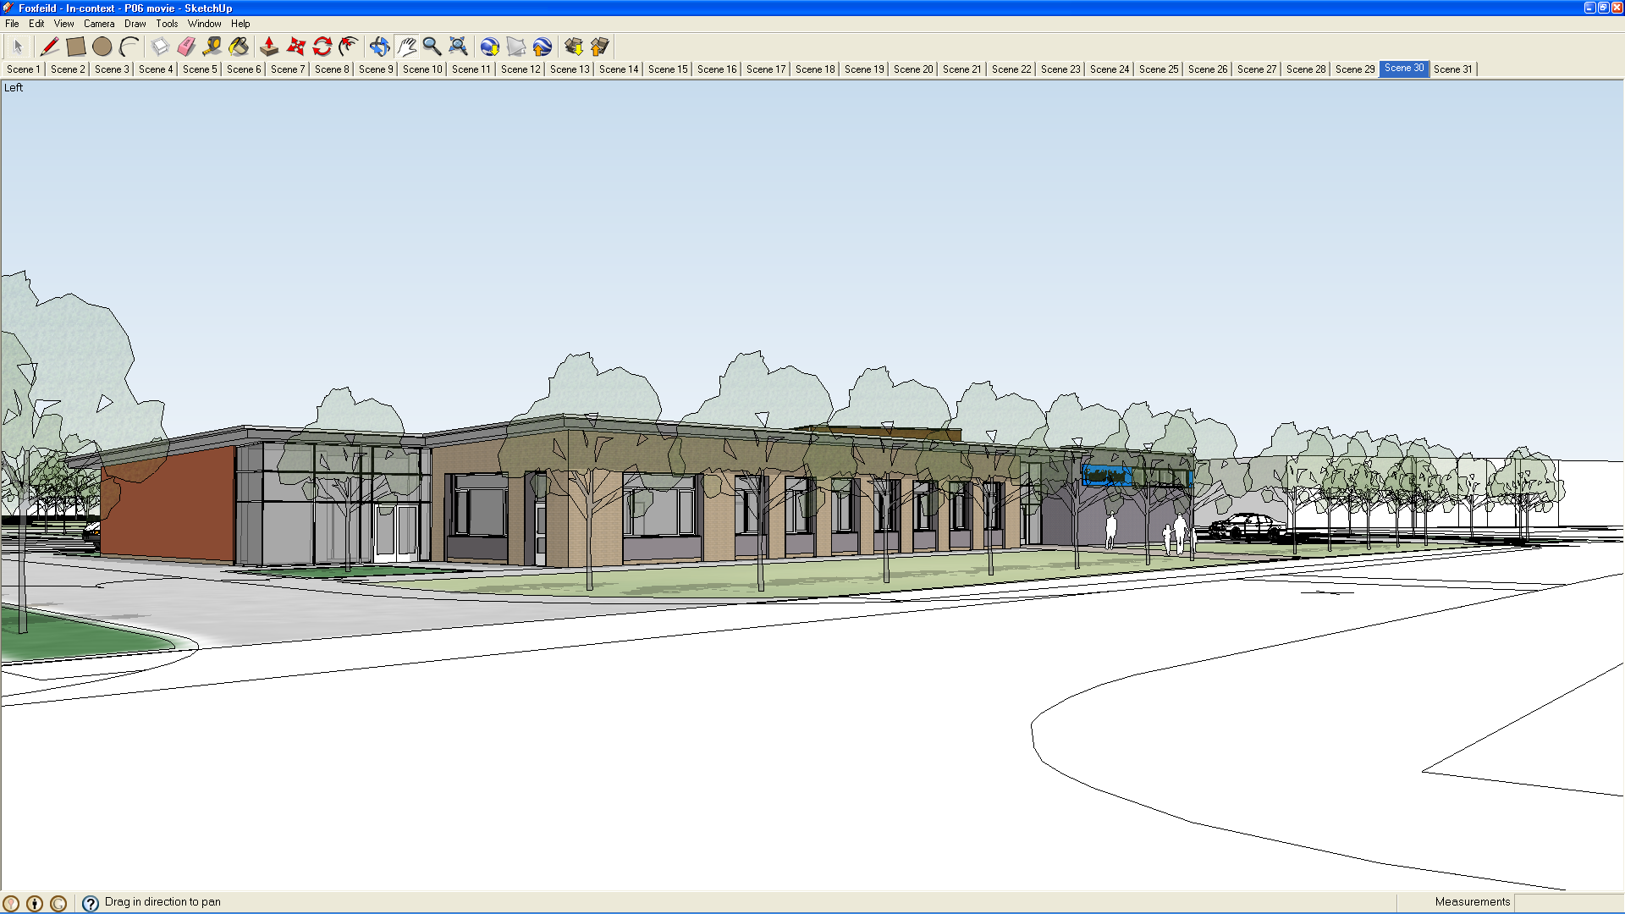

Supervision Policy Document

2020

GENERAL

Staff have a ‘Duty of Care’ towards their pupils. The law has tended to take the view that high levels of care are required because of pupil numbers, and lack of knowledge (compared to that of the parent). However the law also realises that it is impossible to cover every eventuality.

Our pupils have a variety of special needs, and some pupils may indeed need high levels of supervision. This is what their parents/guardians would expect. Members of staff need to be aware of medical/behavioural problems that require very high levels of supervision. This information is contained in their behavioural and/or care plans and their pupil profiles.
The headteacher, in consultation with the staff, is responsible for maintaining adequate supervision levels.

LEVELS OF SUPERVISION
No document consulted has given any suggested ratios for supervision, except in the case of specific (sporting) activities where MAXIMUM numbers may be given (e.g. no more than 1:10). All documents consulted list the variables which will affect judgements and these are described in more detail in the paragraph in the second half of this document (Trips out of school).

Work Experience students and parents should not normally be asked to supervise pupils on their own. However, official Volunteers may be asked to supervise pupils on their own at the discretion of the Head teacher.

SUPERVISION AT BREAK/DINNER TIMES
The teacher in charge of a group must ensure that there is adequate supervision at these times (i.e. as laid down in the rotas) be it in class, in the playground or the hall. Staff must not go for breaks until supervision is properly present. If supervision is not adequate then the teacher should inform the Head, Deputy or person in charge. They should only do this if they have
first tried to rearrange staffing, and/or considered changing arrangements e.g.

pupils remaining in class rather than going to the playground or staying in
their outside play areas.. A lunch time supervision rota is produced each year in September to make sure there is adequate supervision in the playground at all times. (See appendix 1)

IN THE PLAYGROUND
Due to the nature of our playground it is essential that when supervising outside all staff work to support all pupils not simply those in their class groups.
A named person is responsible at lunch time play for ensuring overall supervision is adequate and staff are deployed to cover all blind spots. At all other times class staff must make sure pupils are safely within a designated zone of the playground.

Staff must be deployed so that they can see the whole of the playground that they are responsible for on the playground plan. (See Playground Supervision Policy appendix 1). Staff should be aware that there are a number of problem areas which should be kept under close scrutiny.

HALL
There are four possible exit routes from the hall

- The doors into the gym

- The fire exit onto the Car Park

- Door onto the playground

- Down the corridors through the non - walled side of the Hall

It is acceptable to lock the doors into the gym to aid supervision. This still leaves three exit routes. One member of staff should be near the available exits.

IN THE DINING HALL
Each class makes individual arrangements for supervision in the dining hall. Extra help comes from the Supervisory Assistants. Any problems should initially be referred to the Supervisory Assistants, and then to the Head, Deputy or senior Manager.

BEFORE AND AFTER SCHOOL
Pupils make their own way to classrooms with the help of bus escorts and some classroom staff (this is negotiated when and where necessary).

At 2.45pm the timer is enabled which allows the gates to open automatically
when a vehicle is in the proximity of the gates.. Late buses should not be allowed onto the yard after 3.00pm as this is close to the time when pupils will be walking out to their buses.

At 3.05pm some pupils are escorted to their buses by classroom staff, others make their own way to the buses as part

of their independence training; escorts wait by their buses and will signal when
they have all their allocated pupils. There are also designated wheelchair escorts and a late bus duty team is available each week to supervise pupils whose buses arrive late. This supervision will take place in the covered shelter in the yard or when the weather is inclement pupils can wait with the allocated staff in the hall.

SENSORY / SOFT PLAY ROOMS
Staff should always be aware of their vulnerability when working alone with pupils in a room that cannot be overlooked. However reference is made to this fact in the Intimate Care Policy which mentions this sort of supervision (See Intimate Care policy).

OTHER AREAS OF SCHOOL
The following areas of school are potentially dangerous and added vigilance is needed

- The pools (See Swimming Pool Policy)

- The gym

- The Food Tech Room

- Art and DT Room (Kiln)

- Adventure playground

- All outside areas

- The kitchen (which is out of bounds to all pupils).

- Boiler Rooms and Plant Rooms (which is out of bounds to all pupils).

- Staff Room (Hot Water Geyser)

TRIPS OUT OF SCHOOL
These form a large and important part of the curriculum.

All pupils should have a signed consent form for those trips which form part of the designated curriculum i.e. ILS. (Check that parents signed the consent forms in the Induction Packs when the pupil first started school).

N.B.
All other trips whether day trips, one off occasions or Residentials should have separate written permission. e.g. narrow boats, sports trips, key stage visits to the cinema, etc.

NORMAL WEEKLY TRIPS OUT OF SCHOOL (as part of the curriculum)

PREPARATION
All trips should be planned and have a specific educational purpose. Objectives
should be clearly recognised by staff and pupils.

The teacher is in charge of the group and must ensure that;

- pupils have appropriate clothing
- medication is taken for those who require it
- the Evolve form has been submitted a minimum of 3 days before the planned trip. A hand written list of pupils and staff will also need to be left in the office as a quick reference guide in the event of fire alarm activation.

The teacher must make sure that a member of staff has a mobile phone to
contact school in an emergency and the number of this phone should be written
down on the Evolve form in case school needs to contact or recall a group.

SUPERVISION LEVELS IN THE COMMUNITY
The Handbook on Health and Safety states:

“There is no ‘right level’ of supervision”
This is particularly the case in our school. In general the same groups will be making similar trips every week therefore it is important that at the
beginning of the year teachers assess the group they have. There is adequate scope with team teaching and use of non-

teaching assistants to be flexible in arrangements for trips out.

The level of supervision must realistically reflect the purpose, and nature of the trip, the age and maturity

of the pupils, any behavioural problems and the experience of accompanying staff.

If any member of staff is not happy with their ability to supervise a particular
group they should discuss this with the Head Teacher or the Educational Visits Coordinator (EVC) which at Foxfield School is the Deputy Head teacher.

N.B.
No one should go out with a group if they are not happy with supervision levels available.

Remember also that if there are changes to the group, either pupils or staff, then a reassessment should be made and the Evolve form adjusted accordingly. Supply staff should not automatically be expected to continue with a trip if they have a difficult group and little experience.

WORK EXPERIENCE
Work experience is an entitlement and an extension of the I.L.S. Careers and
Pupils are usually supervised to and from placement and where appropriate supported in the placement. Parents
permission is sought before allowing pupils to travel independently and to take part in the work experience placement.

ADDITIONAL INFORMATION
Members of staff should take money for emergencies and telephone calls.

DAY TRIPS NOT PART OF THE NORMAL CURRICULUM,
OR ONE OFF TRIPS

All previous statements are valid, and in addition the teacher in charge must:

- Leave clear indication of the itinerary.

- Ensure there are appropriate numbers of staff.

- Make contingency plans if they are delayed or there is an emergency.

- Should not deviate from the original plan and destination (as far as possible).

N.B.
No further measures are required providing the activities are NON HAZARDOUS. If they are hazardous
then you should refer to the Educational Visits policy document.

TRIPS WITH AN OVERNIGHT STAY
Any member of staff organising such a stay MUST read the Educational Visits
policy available from the School Office. This does not include flat stays.

HAZARDOUS ACTIVITIES
Refer to Educational Visits policy document before planning any residential trip.

Parents will be given information about these trips therefore copies of standard forms and letters are found in the appendix of the Educational visits document.

If you are staying overnight you should read the emergency procedures laid down in the LA guidelines.

EMERGENCY PROCEDURES
In the event of a major incident when a group is out of school certain procedures must be followed.

A major incident is defined as:

‘A fracture, an amputation or any other illness or injury requiring immediate medical treatment, and /or hospitalization for more than twenty
four hours. In some cases a death may have occurred’.

The following is Local Authority Policy, and is from their policy document H010/93.

In spite of good planning and organisation there may be accidents and emergencies which require an on-the-spot response by the leaders. Very few

fatal accidents have occurred on educational visits, journeys and expeditions, but leaders should be
prepared for this or other emergencies. The following outline guidance is provided for leaders.

CONTROL AND SUPERVISION OF THE GROUP
Ensure the following points are followed.

- Share the problem;
advise all other group staff that the accident/emergency procedure is in operation.

- Make sure ALL members of the group are accounted for.

- If there are injuries, immediately establish the names of the injured people and the extent of their injuries.

- Ensure that the injured are accompanied to hospital (preferably by an adult they know).

- Ensure that the rest of the group are adequately supervised and have understood what has happened and the implications for the rest of the programme.

CONTROL OF INFORMATION AND COMMUNICATION

Restrict access to telephones until you have made contact with the coordinator, Head teacher, provider or emergency contact point.

News travels very quickly. Immediately make contact with the Head teacher, provider or emergency contact point.
Give details of the accident or emergency.

TEACHERS/SCHOOL STAFF
Report to the Head teacher through a contact person at school – This person should be identified on the Evolve form. The Head teacher will inform the Chair of Governors and Director of Children’s Services.

The Authority may be asked for comments or to give direct assistance
(e.g. payment for overnight accommodation, provision of transport).

Contact with relatives should be made by the Head teacher/senior youth officers or provider. Ensure that relatives are informed before the media.

A designated person should act as the ongoing point of contact with the media.

This will involve close liaison with the chief officer.

There should be liaison by the designated person with police and relevant emergency services about what information may be released to the media.

If comment at the scene of the accident or emergency is requested by the media
enquiries should be addressed to the designated person.

The names of participants injured should NOT be released. Caution is required in the preparation of any statement as legal proceedings may follow an accident

(e.g. against a coach company, travel operator, hotel etc.)

You should prepare a written report for the responsible authority of the
accident or emergency at the earliest opportunity and while events are readily
recalled. Note the names, addresses and telephone numbers of any independent witnesses.

The Reporting of Injuries, Diseases and Dangerous Occurrences Regulations 1985 requires the reporting of all major injuries, dangerous occurrences etc., the
LA Policy and Guidance document Accident & Incident V6 Nov 2013
must therefore be consulted.

WELFARE OF MEMBERS OF THE GROUP AND THEIR FAMILIES
In the event of an accident, young people will need help in coping with shock or trauma. This will also apply to leaders, families and other members of the party.

REPORTING OF MINOR INCIDENTS
Schools have a duty to report all accidents to pupils/teachers/young people/volunteers. For this purpose an incident/accident form (M13) should be filled in and in the case of a restraint a

Sleuth report should be generated. These forms are to be completed as described in the LA Policy and Guidance document Accident & Incident V6 Nov 2013.

INSURANCE
See policy document ‘Combined Liability’ – May 2012 for details. In brief:

All staff are covered by:

PUBLIC LIABILITY INSURANCE,
This covers claims from “Third Parties” who could be pupils, their parents, visitors etc. Claims would usually be in
respect of injury or loss of or damage to property.

Insurance will generally expect all staff (paid or voluntary) to have experience and expertise in the activity concerned.

EMPLOYEES LIABILITY
This insurance allows staff to claim for injury sustained while employed. There are other ‘Personal Accident’ policies
which cover specifically; Teachers, Outdoor Education workers, Voluntary workers, Work Experience pupils, Assault.

N.B. Pupils are NOT covered for accidents, i.e. if negligence cannot be proved (such as tripping and breaking an arm

SUMMARY
Ensure that a risk assessment has been undertaken for any out of school activity, especially when visiting new
venues. All risk assessments are on the intranet, any new assessments completed

should be given to the ICT technician to add to the intranet site.

If you are going on any trip involving a hazardous activity or an overnight stay you must read the Educational visits
policy, obtain parental consent, and fill in an Evolve form which must be presented
at least 10 days before that activity is due to take place.

GUIDANCE DOCUMENTATION

Health and Safety guidance documents December 2013 to February 2015 (available on WESCOM)

Educational Visits and Off Site Activity – Policies and Guidance June 2014
(available on WESCOM)

Appendix 1

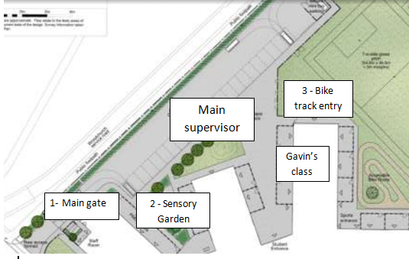
Playground supervision
3 - Bike track entry
Gavin’s class
April 2015
There will be a nominated person in charge on the playground each day. This may be a teacher or TA3. This person is to ensure that all key areas are supervised. It is vital that the main gate is covered and pupils are only allowed into the playground once this gate is supervised.

Michelle’s class will be used as an indoor play area for any pupils who cannot access the playground.

All staff will:
- Ensure that they do not take pupils onto the playground until it is appropriately supervised
- Supervise all pupils – you are not solely responsible for your class, you are supervising pupils in an area.
- Supervise pupils in an area – if that area has no pupils in it, move to support the pupils nearest your designated area.
- Ensure that any specific behaviour strategies are communicated with staff across the key stage.
- Ensure that pupils have access to stimulating resources to play with on the playground
- Respect the use of the playground and not bring the bus onto the yard between 12.30 – 1.
- Know that Ian, Erica and Micah are not on this rota due to the complex demands of their class groups. Their classes are expected to support the key stage on the play ground and without their pupils and staff being out our whole key stage play time will not work.
The main supervisor will:
- Ensure that if they cannot do their playground duty for any reason they find another appropriate person to cover their duty. This must be a member of Foxfield staff.
- Know that Ian, Erica and Micah will be expected to cover when others cannot do their duties due to absence in their classes. It is up to the class on duty to negotiate this allowing plenty of notice.
- Ensure that all areas are covered with an appropriate level of staffing.
- Carry the key to the gates and allow access to fitness equipment if staffing levels allow.
- Give out the playground FISH to staff as they appoint them to an area of the playground ensuring that all key areas have a member of staff with a FISH
- Pass FISH on to the person supervising the following day.
Monday | Tuesday | Wednesday | Thursday | Friday
Michelle | Gavin | Steve | Lydia | Michelle/ Steve

