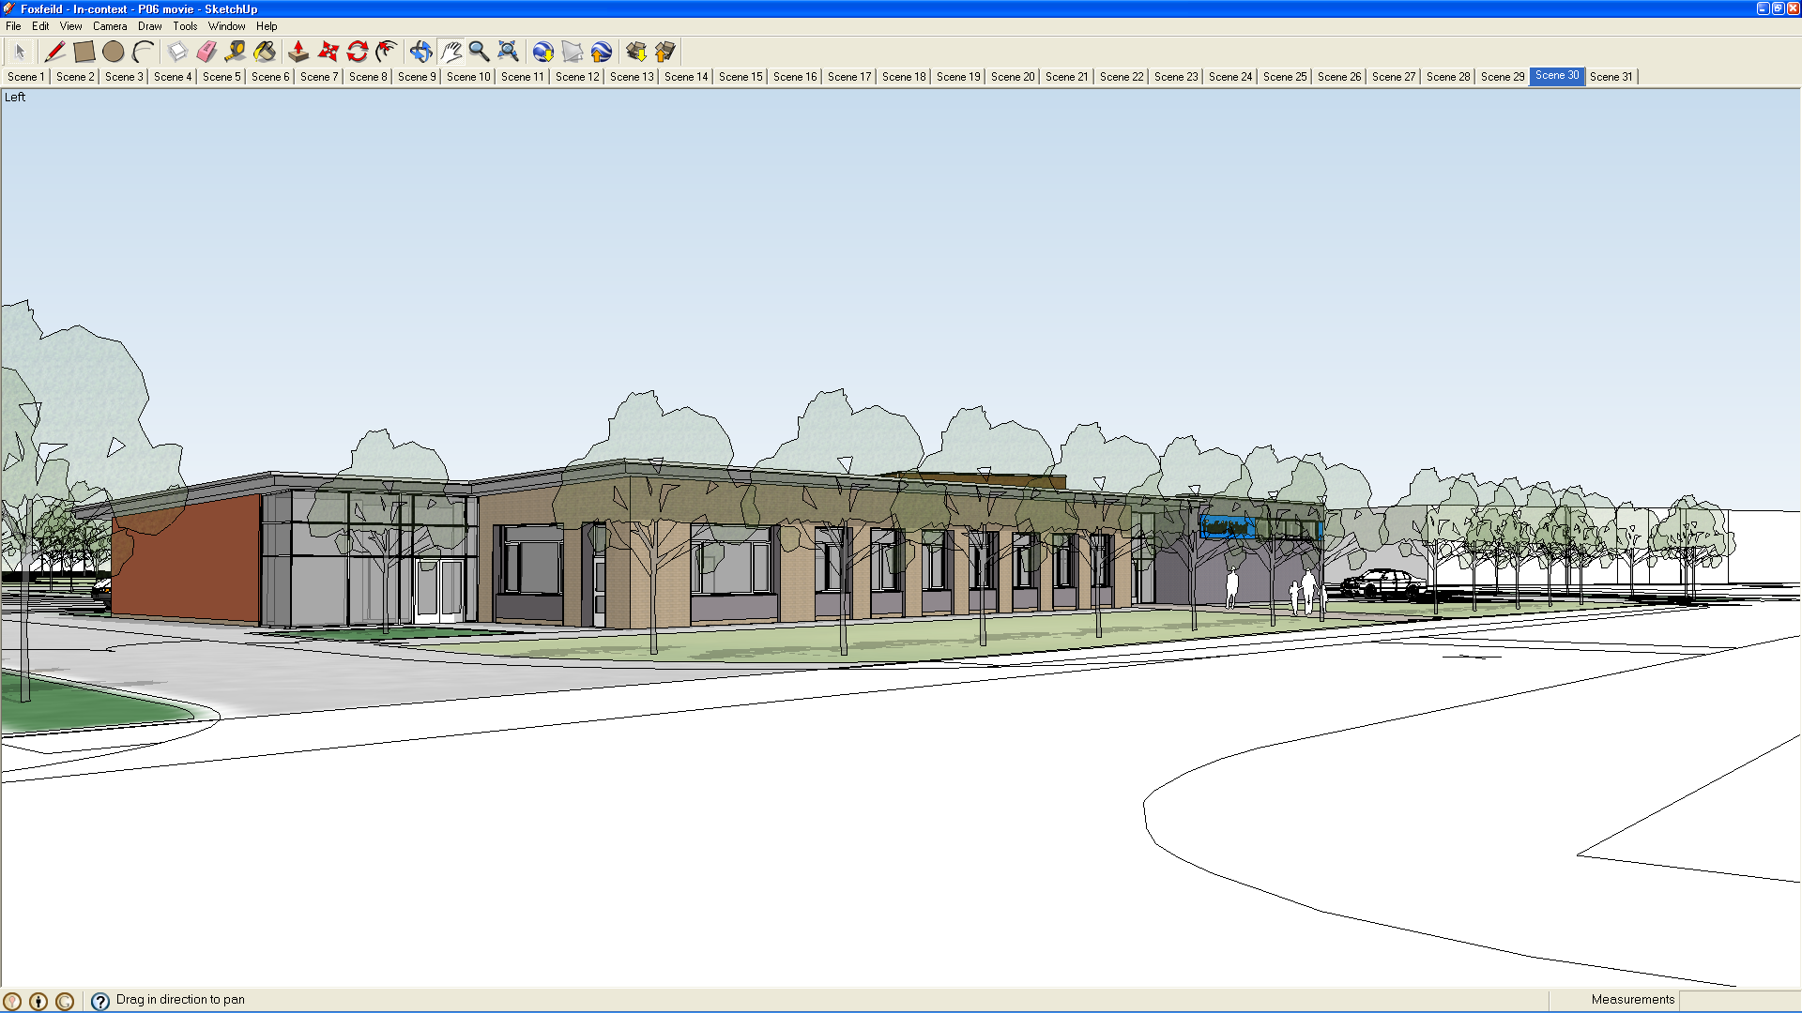

We have a duty by law to report accidents to pupils, staff or visitors to school. Staff must be aware of their responsibilities.

ACCIDENTS

ACCIDENTS TO PUPILS AND STAFF

Due to the Data protection act people are no longer required to fill in forms M36 and BI 510 after an accident. The new M13 form still needs to be filled in and signed by the Head Teacher or one of the deputies. Two copies should then be made so that one copy can be retained by the person who has had the accident (in the case of a pupil, it should go in the back of their file). One copy should be entered into the accident file which will be kept in the Head Teacher office for purposes of confidentiality. The third can then be sent to the health and safety department of the education authority, if deemed serious enough to warrant doing so, (see below for address).

MINOR INJURY

Fill in Form M13

MAJOR INJURY (Requiring hospitalization)

Fill in Form M13

Reporting incidents and accidents
2020

ACCIDENTS TO STAFF

All injuries fill in Form M13
Fill in a school incident form with details of how it was done.

If you have filled in a Form M13 and the injury is deemed to be serious enough, these should be sent to the Health and Safety Officer, Buildings Service,

Hamilton Buildings, Conway Street, Birkenhead

You should therefore:

- Inform the Head Teacher or a deputy

- If not available inform another senior member of staff

- Photocopy Form M13, place one copy in the file kept in the Head Teacher room, retain one for self or pupil and one (if deemed a serious enough injury), in an envelope addressed to Health and Safety Officer, Building Services, Hamilton Buildings, Conway Street, Birkenhead.

HEALTH AND SAFETY COORDINATOR

- Keep a check on accidents reported, and look for trends either in location or personal.

- Ensure Form M13 is sent to the office.

If the accident is very serious report by telephone to the office (666 4273, or 666 4270). If the Head Teacher or one of his deputies is not available, the person must report the incident to a senior member of staff who will report this to the above numbers.

INCIDENTS

As well as accidents other incidents may occur. These may involve an accident (see previous section) and allow for a fuller report than is contained in the official forms.

The type of incident reported may be damage to property, assault by one pupil on another, restraint, or a pupil going missing while out on a visit. Accident forms must be filled in on all occasions and presented to the Head Teacher or the Deputy for signing. A copy of this can then be taken with one being placed in the

Accident book, one placed in the pupil file, and another sent to the authority.

ACCIDENT files are kept in the Deputy Head Teachers office for reasons of confidentiality

NOTIFYING PARENTS

In the case of accidents in school parents will be informed by means of a chat book or phone call, depending on the seriousness of the injury. Particular care should be taken with

- Bumps to the head.

- Accidents to pupils who are non verbal and may find it difficult to communicate their distress.

It is envisaged that in all cases of any seriousness the teacher or senior staff will try and contact the parents by telephone. However for a graze or bruise the form will be enough.

N.B. Remember that although a minor graze may seem unimportant, to a parent their child returning home with a plaster or bruise can be very upsetting. By writing home it shows to them that we are as concerned as they are and that we see it as good practice to keep them informed.

Foxfield also has an electronic way of recording incidents and accidents called SLEUTH. (For more detailed information see Behaviour Documentation and Policu).

