Charges, Voluntary Contributions & Remissions
2020
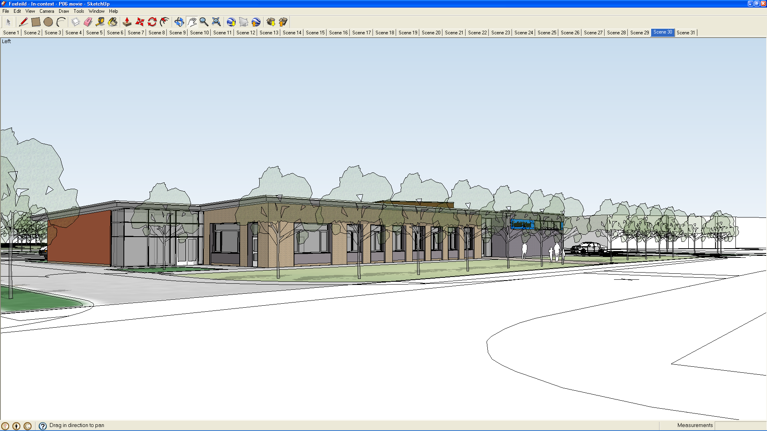

We believe this policy relates to the following legislation:

- Education Reform Act 1988
- Education (Prescribed Public Examinations) Regulations 1989
- Education (Pupils' Attendance Records) Regulations 1991
- Education (School Sessions, Charges and Permissions Policies) (Information) (England) Regulations 1999
- Education Act 2002
- Education and Inspections Act 2006

We are aware that under the Education Reform Act 1988 and the Education Act 2002 that no charge can be made for education in school hours and that every child has the right to receive free school education.

We recognise that all activities offered during normal teaching time must be made available to all children regardless of their parents’ ability or willingness to help meet the cost.

We recognise the valuable contribution that the wide range of additional activities, including clubs, educational visits and residential experiences, can make towards pupils personal and social education.

It is our intention to promote and provide such activities both as part of a broad and balanced curriculum and as additional activities.

Therefore, any activity which takes place mainly during school hours or is an essential part of the curriculum will be provided free of charge.

We are aware that we are able to ask for voluntary contributions from parents when organising educational visits which will enrich the curriculum and the educational experiences of children.

We as a school community have a commitment to promote equality. Therefore, an equality impact assessment has been undertaken and we believe this policy is in line with the Equality Act 2010.

Aim

- To outline what the school can and cannot charge for.
- To outline the school policy for voluntary contributions and remissions.

Responsibility for the Policy and Procedure

Role of the Governing Body

The Governing Body has:

- delegated powers and responsibilities to the Headteacher to ensure all school personnel and visitors to the school are aware of and comply with this policy;
- responsibility for ensuring that the school complies with all equalities legislation;
- responsibility for ensuring funding is in place to support this policy;
- responsibility for ensuring this policy and all policies are maintained and updated regularly;

- responsibility for ensuring all policies are made available to parents;
- nominated a link governor to visit the school regularly, to liaise with the Headteacher and to report back to the Governing Body;
- responsibility for the effective implementation, monitoring and evaluation of this policy

Role of the Headteacher

The Headteacher will:

- ensure all school personnel, pupils and parents are aware of and comply with this policy;
- work closely with the link governor and coordinator;
- provide leadership and vision in respect of equality;
- provide guidance, support and training to all staff;
- monitor the effectiveness of this policy;
- annually report to the Governing Body on the success and development of this policy

Conditions when charges cannot be made

Charges cannot be made for any books, materials, instruments, equipment or transport for use in connection with education if the education is:

- within school hours;
- for the National Curriculum programme out-of-school hours;
- part of a syllabus for an agreed examination for a pupil;
- for statutory religious education;
- for musical tuition as part of the National Curriculum;
- for education provided on any educational visit during the school day;

- for education provided on any educational visit outside school hours;
- for the cost of supply teachers substituting for absent teachers on residential visits with pupils;
- for the entry to public examination which is on the prescribed list;

Charges for transport cannot be made when:

- transporting pupils to or from the school premises;
- transporting pupils to other premises where arrangements have been made for them to be educated;
- a pupil needs to sit an examination;
- an educational visit has been planned

Conditions when charges can be made

Charges can be made when:

- a parent/carer wishes their child to own any specific materials, books, instruments or equipment;

Charging for Optional Extras

Charges may be levied for:

- optional extra activities if parents are
willing to accept a charge for the costs;
- an activity that takes place outside
school hours;
- any activity provided they do not
exceed the actual cost of the activity;
- the cost of board and lodging on a
residential visit;
- transport provided for any activity;
- musical tuition that is not part of the
National Curriculum

Support for Parents/Carers

The Governing Body will:

- support any parent/carer in paying for any activity for an individual pupil if they are experiencing financial difficulties;
- create a school fund that will support parent/carers who are unable to pay voluntary contributions

Voluntary Contributions

We are aware that we can ask for voluntary contributions from parents/carers that will benefit the school or any school activity.

We will inform parent/carers:

- if planned activities depend on voluntary contributions for part or all of the cost;
- that there is no obligation on them to make voluntary contributions;
- that no pupil will be excluded from an educational visit or activity if a parent/carer is unwilling or unable to pay;
- that a school fund will assist those parents who are unable to pay voluntary contributions

Remissions

We will remit any charge wholly or partly if any activity takes place:

- mostly within school hours or;
- partly within and partly outside school hours

Equality Impact Assessment

Under the Equality Act 2010 we have a duty not to discriminate against people on

the basis of their age, disability, gender, gender identity, pregnancy or maternity, race, religion or belief and sexual orientation.

This policy has been equality impact assessed and we believe that it is in line with the Equality Act 2010 as it is fair, it does not prioritise or disadvantage any pupil and it helps to promote equality at this school.

Monitoring the Effectiveness of the Policy

The practical application of this policy will be reviewed annually or when the need arises by the coordinator, the Headteacher and the nominated governor.

Residential Visits

- School trips and visits form an important part of the curriculum offered by our school. Parents are not required to pay for such visits, but may be asked to make voluntary contributions towards their cost. No pupil will be excluded from a school trip because of his or her parent’s unwillingness or inability to contribute, but it is hoped that parents will feel able to support the school in its efforts to provide a full and interesting curriculum for all its pupils. If the contributions made are not sufficient to enable a planned trip to take place, the Headteacher may cancel the trip or make such changes to the organisation of the trip as they think necessary.

- All trips and visits will be organised under the direction of the

Headteacher and / or Educational Visits Coordinator (EVC = Deputy Head Teacher) and in accordance with the guidelines issued by Wirral Local Authority under the EVOLVE scheme.

- Parents are asked to meet the board and lodging costs of residential trips.

- If they are unable to do so the School will look for alternative funding sources. No pupil will be excluded from participating in a residential trip because their parents or carers cannot make a financial contribution.

- Parents may be charged for activities defined as “optional extras” activities which are provided mainly out of school hours and which is not part of the school curriculum. If parents would like their children to take part in such activities but are unable to meet the full cost, financial assistance may be available.

- Parents maybe asked for payment towards the cost of repairing or replacing any part of the fabric of the school or item of school property, which has been damaged or lost as a result of their child’s behaviour.

After School Clubs

- All pupils are given the chance to take part in a variety of after school clubs which run on a Monday and Wednesday evening from 3.15pm to 4.15pm.

- Parents are asked to make a small voluntary contribution towards the running of these clubs.

Summer Play Scheme

- All pupils are given the chance to take part in a summer play scheme at Foxfield School. The scheme runs for four weeks in the summer term with each pupil being given a chance to attend twice a week.

- Parents are asked for a small voluntary contribution towards the running costs of the scheme i.e. covering entrance charges to particular venues, transport costs, refreshments etc.

N.B.
For other charges the school may make see Lettings Policy.

Initial Equality Impact Assessment

Policy Title | The aim(s) of this policy | Existing policy (✓) | New/Proposed Policy (✓) | Updated Policy (✓)
 |  |  | ✓

This policy affects or is likely to affect the following members of the school community (✓) | Pupils | School Personnel | Parents/carers | Governors | School Volunteers | School Visitors | Wider School Community

Question | Equality Groups |  |  |  |  |  |  |  |  |  |  |  |  |  |  |  |  |  |  |  |  |  |  |  | Conclusion
Does or could this policy have a negative impact on any of the following? | Age |  |  | Disability |  |  | Gender |  |  | Gender identity |  |  | Pregnancy or maternity |  |  | Race |  |  | Religion or belief |  |  | Sexual orientation |  |  | Undertake a full EIA if the answer is ‘yes’ or ‘not sure’
 | Y | N | NS | Y | N | NS | Y | N | NS | Y | N | NS | Y | N | NS | Y | N | NS | Y | N | NS | Y | N | NS | Yes | No
 |  | ✓ |  |  | ✓ |  |  | ✓ |  |  | ✓ |  |  | ✓ |  |  | ✓ |  |  | ✓ |  |  | ✓ |  |  | ✓
Does or could this policy help promote equality for any of the following? | Age |  |  | Disability |  |  | Gender |  |  | Gender identity |  |  | Pregnancy or maternity |  |  | Race |  |  | Religion or belief |  |  | Sexual orientation |  |  | Undertake a full EIA if the answer is ‘no’ or ‘not sure’
 | Y | N | NS | Y | N | NS | Y | N | NS | Y | N | NS | Y | N | NS | Y | N | NS | Y | N | NS | Y | N | NS | Yes | No
 | ✓ |  |  | ✓ |  |  | ✓ |  |  | ✓ |  |  | ✓ |  |  | ✓ |  |  | ✓ |  |  | ✓ |  |  |  | ✓
Does data collected from the equality groups have a positive impact on this policy? | Age |  |  | Disability |  |  | Gender |  |  | Gender identity |  |  | Pregnancy or maternity |  |  | Race |  |  | Religion or belief |  |  | Sexual orientation |  |  | Undertake a full EIA if the answer is ‘no’ or ‘not sure’
 | Y | N | NS | Y | N | NS | Y | N | NS | Y | N | NS | Y | N | NS | Y | N | NS | Y | N | NS | Y | N | NS | Yes | No
 | ✓ |  |  | ✓ |  |  | ✓ |  |  | ✓ |  |  | ✓ |  |  | ✓ |  |  | ✓ |  |  | ✓ |  |  |  | ✓

Conclusion | We have come to the conclusion that after undertaking an initial equality impact assessment that a full assessment is not required.

Preliminary EIA completed by | Date | Preliminary EIA approved by | Date

