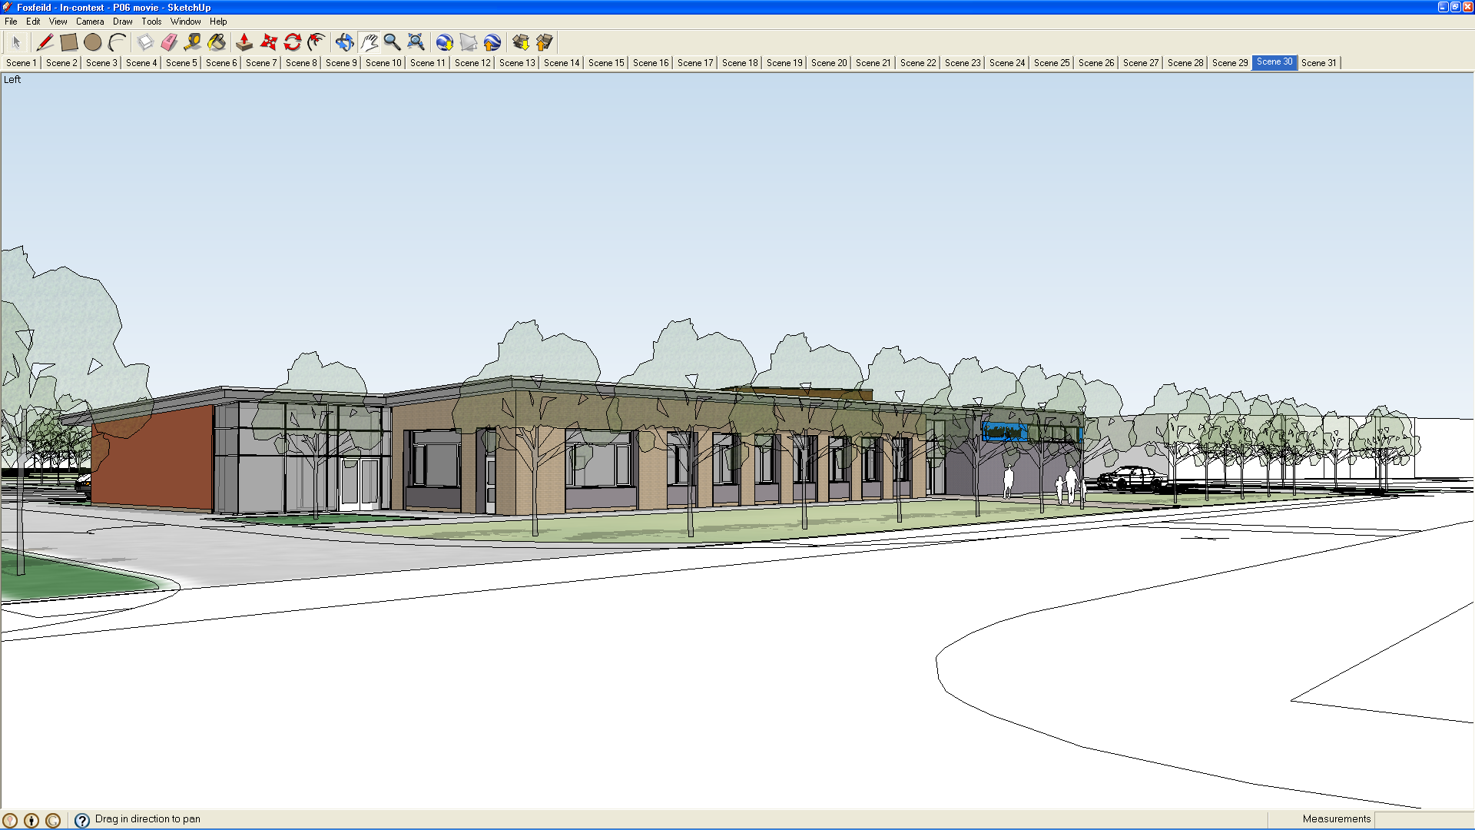
Teacher Planning 2020

PLANNING AT FOXFIELD SCHOOL

1. INTRODUCTION

1.1 ”Effective planning involves the careful and deliberate sequencing of curriculum content and experiences which build on previous learning and achievements to promote future learning. Long- and medium-term curriculum plans should provide for, and show progression from, age group to age group and within each of the four key stages. These plans will enable teachers to design and implement learn opportunities in their short-term planning which promote progress and achievement for all learners.

“For pupils with learning difficulties, progression is not necessarily only movement up a hierarchical ladder of skills and knowledge. Lateral progression is also important”. (1)

2.1 Teacher planning at Foxfield has been designed using the guidelines provided by the DFEE in the document entitled “Planning, teaching and assessing the curriculum for pupils with learning difficulties.” QCA March 2001

3.1 There are four stages within the teacher planning at Foxfield;

- Policy Making
- Long-term planning
- Medium-term planning
- Short-term planning

2. POLICY MAKING

2.1 The curriculum policy of the school outlines the structure of the curriculum at each Key Stage. It details the contents and balance of the National Curriculum subjects where appropriate and the additional elements within the school curriculum that complement this.

2.2 Subject leaders are responsible for the implementation and reviewing of the policy document in relation to their subject. Policy documents are located on the Foxfield intranet under their relevant subject.

3. LONG-TERM PLANNING

3.1 Long-term plans “help to secure pupils’ shared entitlement to breadth of experience. Staff may decide to adjust the balance of the curriculum and to focus on the priority areas of learning by ensuring their planning accommodates group or individual plans.” (2)

3.2 Long-term plans have been produced for all subjects within the school curriculum. These outline the content of the subject and work to be covered across each Key Stage. For many of the foundation subjects of the National Curriculum these plans span Key Stages 3 and 4, while the core subjects of the curriculum are laid out in long-term plans that cover the full 11 – 19 curriculum. Long - term plans also distinguish between the subjects that are delivered continually and those that are delivered through a Cross - Curricular approach.

4. MEDIUM-TERM PLANNING

4.1 Medium –term plans follow the curriculum as determined through the long - term plans. They represent the work that is planned to be covered within a specific time period, such as a half-term or term. They outline the theme of the module of work and the sequence of activities to be covered, usually with some indication of the time span involved. In addition there will be differentiated learning outcomes that the teacher wishes to teach during the module.

4.2 There will be occasions when teachers use their professional judgement to adapt their medium –term plans to respond to the progress that individual pupils or entire classes are making. This is quite acceptable and in keeping with the provision of appropriate relevant differentiated learning experiences that meet the pupils’ needs.

5. SHORT-TERM PLANNING

5.1 Short Term Planning is now contained within a more detailed Medium Term Plan.

5.2 Medium term plans are regularly reviewed and expanded upon to form a detailed outline of specific lessons and are similar in detail to short term plans covering a single lesson.

5.3 The essential elements of short-term planning and lesson preparation require the teacher to address the following areas which are also contained within the medium term planning;

- Learning outcomes
- Learning objectives
- Lesson format (to include introduction, starter, main teaching and learning activity and plenary)
- Key words
- Resources / deployment of support staff
- Use of ICT and computers
- Assessment / Recording

Differentiation of work should be highlighted within the main teaching and learning section of the medium term plan

5.4 At Foxfield School there is a standard format for Medium Term planning across all key stages.

5.5 Teachers will be required to keep copies of their short-term planning either in paper form or on their computer hard drive for the academic year and copies are given to the Head teacher for scrutiny at the beginning of each term.

6. CROSS CURRICULAR

Cross curricular subjects are planned in the same way as others with the long term plan forming a rolling programme for DT, Art, History and Geography. Individual

teachers plan their delivery in one of two ways. Firstly they can deliver all four subjects on a weekly basis in a topic or modular format or they can opt for breaking the subjects down in a two weekly alternation of Humanities one week i.e. History and Geography and the arts i.e. Art and DT in the next week.

7.PLANNING FOR ACCREDITED COURSES

Some accredited course areas are planned for discreetly if they do not fit into other aspects of the curriculum, whereas some accredited course areas lend themselves to other subject areas e.g. Position – which will be planned for in speaking and listening, PE, maths (shape space and measurement), ILS, PSD and very much depends upon the ability of the particular group being taught.

8.PLANNING FOR NON – CURRICULAR ACTIVITIES

The way no – curricular activity time is used largely depends upon the Key Stage. In Key Stage 3 pupils are split into groups for PSD on a personal needs basis and according to their targets.Sessiona are then delivered in order to support individuals with specific aspects of PSD such as enhanced SRE lessons through Drama and role play, Lego Therapy etc.

In Key Stage 4 pupils are grouped by social ability and therefore attend specific sessions planned by individual teachers in the key stage. In the autumn term the theme is Interaction and planned activities include Role Play activities, board games, singing and signing and Jabadao. In the spring term the theme changes to Independence and organisation where activities include craft (for lower abiklity pupils), construction, ICT/Computer activities and craft (for higher ability pupils). Finally in the summer term the theme changes to Attention skills and activities include; mindfulness, group games, massage/relaxation and sensory stories.

In the post 16 age phase

Key
(1), & (2) Planning, teaching and assessing the curriculum for pupils with learning difficulties. QCA March 2001

