I.T. and Computer Policies 2020
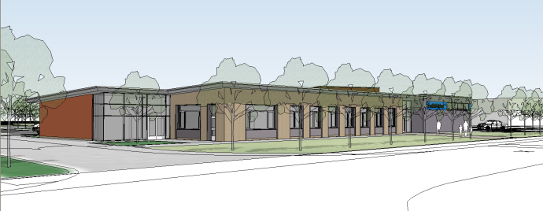

I.T. Strategy Plan
Computer Disaster and Recovery Plan
E Data Storage
Computer E Safety Policy
Whole School ICT and Computing for staff, pupils and visitors at Foxfield School
ICT Resource Deployment
Freedom of Information Policy
Data Protection
Bring Your Own Device Guide (BYOD)
School Clear Desk Policy
School Clear Desk Checklist
Acceptable use of social networking websites policy
CCTV Policy

