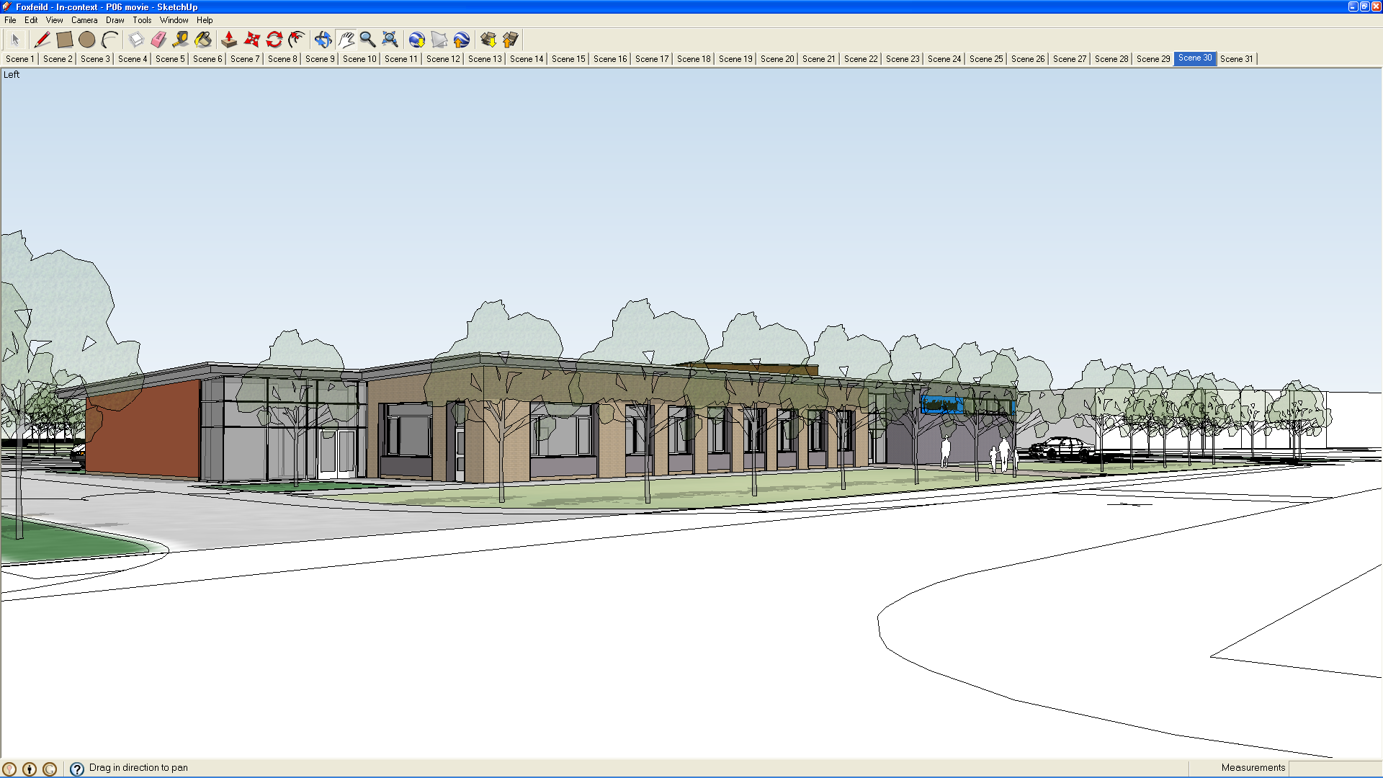
Aims of the school 2020

In accordance with Section 1 of the EDUCATION REFORM ACT 1988 the overall aims of the National Curriculum are accepted by Foxfield School. It says that the curriculum should be balanced and broadly based and should

1 (2) (a) “promote the spiritual, moral, cultural, mental and physical development of pupils at the school and of society”

1 (2) (b) “prepare such pupils for the opportunities, responsibilities and experiences of adult life.”

In addition to these there are aims that are specific to Foxfield School.

The aims of Foxfield School drive all that is done and all that we strive to do, for and with all the students in our school. The aims of the school are the consensus of all staff in school, and have been evaluated and re-written with the support of parents and governors in the light of current legislation and recent developments in education. They have their basis in the rights and entitlement to a quality education for all students at Foxfield School, delivered through a broad, balanced and relevant curriculum.

The aims of the school have been audited and re-written recently, with the help of students, parents, governors and staff.

These aims are as follows:

AIM 1

To enable the young people to achieve their full potential in all areas of their development.

AIM 2

To provide a happy, caring, safe and supportive environment which is stimulating and respectful

AIM 3

To work with everyone involved so that each young person in our school can become increasingly independent and integrate more successfully into the community.

AIM 4

To provide a broad and balanced curriculum relevant to the needs of every young person that attends Foxfield School.

