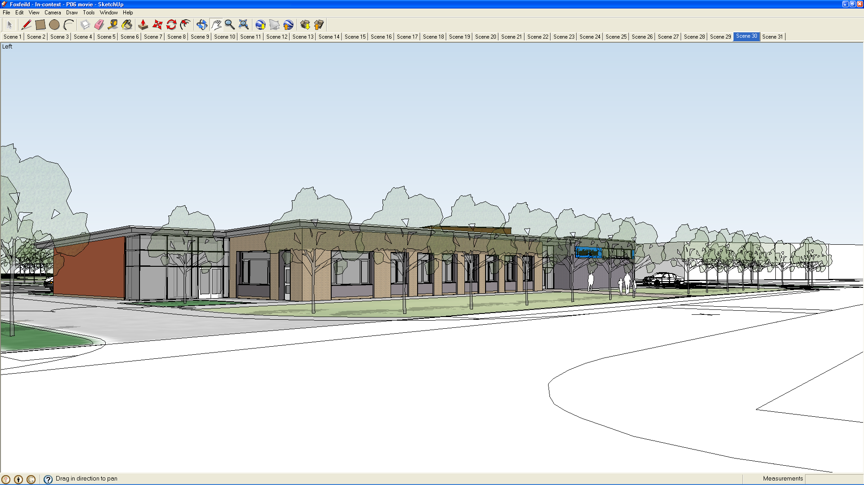
Access Policy and Action Plan 2020

1. Introduction
This Access Policy statement is based on a belief in equality and inclusiveness for all and confirms that everyone should have equal access to facilities and services regardless of disability, age, gender or race. With this in mind Foxfield School puts accessibility for all at the heart of the planning and design process.

The school is committed to providing a fully accessible environment which values and includes all pupils, staff, parents and visitors regardless of their educational, physical, sensory, social, spiritual, emotional and cultural needs. We are committed to challenging negative attitudes about disability and accessibility and to developing a culture of awareness, tolerance and inclusion.

2. Definition of Disability
Disability is defined by the Disability Discrimination Act 1995 (DDA) and the Equality Act 2010: The Act defines disability as when a person has a physical or mental impairment which has a substantial and long term adverse effect on that person’s ability to carry out normal day to day activities. Some specified medical conditions, HIV, multiple sclerosis and cancer are all considered as disabilities, regardless of their effect.

The Act sets out details of matters that may be relevant when determining whether a person meets the definition of disability. Long term is defined as lasting, or likely to last, for at least 12 months.

Foxfield School also considers other legislation in all decision making processes e.g. the SEND Act 2001, the Education Act 2011 (with particular reference to the Education Act 2011 Equalities Impact Assessment) and this Policy
will be updated when new legislation is passed to account for any further duties / requirements of the School.

3. Key Objectives
Foxfield School recognises that many of its pupils, visitors and staff, whether disabled or otherwise, have individual needs when using school facilities. We recognise that for all pupils, the nature of their disabilities may mean that they experience specific difficulties related to accessing education, and the physical environment. As part of the ongoing commitment to the delivery of an inclusive educational service, we will endeavour to ensure that all our pupils receive as high a standard of education as their counterparts in mainstream schools.

In order to ensure that the educational services it provides effectively meet the needs of disabled students the school will:

- Inform staff of this access policy so that the provision of educational services ensures the inclusion of all of our pupils. Such communications will address the legal obligation of staff, and the school.
- Make all prospective employees aware of the disabilities of the pupils in the school. Any applicant for a new position will be made aware of their role in delivering the curriculum, personal care, therapy programmes and maintaining the health and safety of the pupils at all times.
- Provide appropriate training for staff which will explain the school access policy and ensure the effective implementation and monitoring of it.
- Encourage all visitors to school including suppliers and contractors, to adopt similar policies towards disabled students.
- Consult with disabled pupils, parents, staff and disability organisations.
- Regularly review whether its education (and other) services are both accessible and effective, and take appropriate action.
- Monitor the implementation and effectiveness of this plan on a regular basis.
- Operate an accessible complaints procedure whereby disabled people can make improvement suggestions and request assistance.
- Address acts of disability discrimination via existing policies, the school development plan and the asset management plan. As curriculum policies are reviewed, a section relating to access will be added to that on Equality and Diversity.
- Ensure that information about the Accessibility Plan is published on the School’s website.

4. Access to Non-Educational Services within Educational Buildings
Foxfield School also hires the facilities to non-educational and community bodies. This is an important income stream and provides a strong link with the local community

Since October 2004, schools, in the provision of non-educational services to the public, have had to take reasonable steps to remove, alter or provide reasonable means of avoiding physical features that make it impossible or unreasonably difficult for disabled people to access the service.

The provision of non-educational services may include activities such as:
- Governors meetings;
- Services offered to parents, such as meetings to present the annual report, admission and exclusion hearings where an appeal is by the parents;
- Fund raising events organised by parent teacher association.
- Leisure time activities for children or adults without any element of educational development;
- The use of school sports facilities by the local community or the hiring of school accommodation to members of the public.

5. Improving the Physical Environment of Schools
Foxfield School as an SEN establishment has been designed to be accessible for all users having space in which people can easily move, interact and use the physical features. Employees are part of the school, both in terms of their own interaction with pupils and parents, and also the ease with which they work within their physical environment.

The school has entrance and exit points for vehicles and pedestrian access.

All areas around the school are on one level and accessible to all. Ramps are provided for use by wheelchair and ambulant users. Access around the school can be restrictive as the school has to take into account the pupils and security issues around the site. Consequently there are a number of areas where extra security is installed to prevent a pupil running away and behaving in a way that may cause a risk to themselves or others.

Foxfield School has extensive grounds which can become outdoor classrooms to reinforce the curriculum and offer experiences at break and lunchtimes. Staff ensure that the ethos of the school is carried into the grounds in all key stages.

The school moved into new purpose built accommodation in 2015 with a new accessible entrance foyer with automatic doors into a reception area. There is access to seating in the reception foyer, an information screen and the availability of the reception team for additional support.

The building is on one level and the dining area is accessible to all.

Accessible toilet facilities are located throughout the building for pupils, staff and visitors and along with additional specialist changing and showering facilities. Specialist hygiene and laundry facilities are available in the school and all water outlets have thermostatic controls. The two pools are used for swimming activities for all pupils, therapy for ASD children and hydrotherapy for PMLD children. Facilities include a hoist, steps, handrails, specialist changing/ shower beds. Users have access to a variety of rooms depending on the activity. The school has two medical rooms that are used by the school nurses during the week and the doctor attending for medicals. The rooms have a sink and are close to toilets.

Fittings in the school are at heights to allow access by the pupils.

Signage around the school adheres to current Health and Safety regulations and there is also signage using the school communication system of symbols/pictures.

Lighting is suitable for purpose in all rooms with blinds in most rooms to allow for adjustable lighting.

Rooms have contrast colours / paint identifying doors from walls to allow for children/people with a visual impairment to distinguish doorways easily.

The school is aware of the affect that noises e.g. lights buzzing, can affect the ability of the children to work and concentrate. This is kept to a minimum and the caretaker undertakes repairs as soon as possible.

The evacuation procedures are displayed around the school and there is a fire drill every term. There is a high staff to pupil ratio to meet the needs of students with disabilities under an emergency evacuation. The School also has evacuation plans for students with severe mobility issues to ensure effective and efficient emergency egress.

Accessible toilets have emergency call alarms activated by cords in case of any problem. The accessible toilets have both lights and alarm sound warning (assistance call) over the doors.

All outside areas are maintained regularly by the caretaker and the gardener and monitored by the classroom staff.

The Caretakers monitor the general internal condition of the school on a daily basis, also monitoring Health and Safety issues and completing statutory building checks. The school staff note any maintenance items for the Caretakers to attend to. Contractors are brought in for issues not within the remit of the Caretaker.

6. Access to the Curriculum.
Foxfield School offers a broad and balanced curriculum for all pupils and, as an SEN school provides additional specialist provision to enable all pupils with learning difficulties to access the curriculum and aid their educational development. The teaching environment / facilities include:

- Teachers and teaching assistants have the necessary training to teach and support disabled pupils through regular INSET days, individual courses and joint training days with other SLD schools on Merseyside.
- Staff work closely with colleagues from the sensory services, Speech and Language Therapy service and the VI and HI staff to ensure that pupils are enabled to access all curriculum opportunities and have appropriate means of communication
- The classrooms are organised for pupils with adaptive equipment, adjustable height seating and worktops if required, and the variety of equipment required to meet the needs of the children.
- Individual targets are set to allow all pupils to achieve to the best of their ability in all lessons.
- All pupils take part in music and physical activities as part of the access to the curriculum.
- Communication systems are used by all staff, including Makaton Pecs, photographs, and objects of reference.
- Staff recognise and allow for the additional time required by our pupils to use equipment in practical sessions.
- Foxfield School provides all pupils with access to computer technology with appropriate adaptations for our pupils.
- School visits are accessible to all pupils irrespective of attainment or impairment.
- There are high expectations of all pupils.
- Staff constantly seek to remove all barriers to learning and participation.

7. Flexibility of Teaching
Foxfield School teachers and support staff are flexible enough to adapt their teaching approaches to enable our pupils to learn effectively in their classrooms.

Foxfield School has high expectations, school staff present work in many different ways using a variety of equipment. Work can be carried out individually, in small groups or the whole class group.

Staff enable the pupils to show their interest, knowledge and skills despite their difficulties with communication. Visual timetables and clues to 'next 'activities are given to ensure the pupil is aware of the routines required throughout the day.

Foxfield’s pupils need to be taught many things that other young people pick up without specific adult help, e.g. how to put things away; how to look after their possessions, how to get dressed independently; meet their own care needs etc. Consequently PSHE and Independent Living Skills work has a prominent position within the school timetable. Reward systems are in place to support the children with positive strategies.
Pupils have behaviour plans to tackle any behavioural issues. The plan is drawn up in conjunction with the parents, social workers, CAMMS staff and behaviour support team members.

8. Arranging the Classroom
Each classroom is set out to provide the most positive environment to work in, to ensure the pupil learns effectively. Classrooms have sufficient space for all the pupils. Toilet s are available close to each classroom. Signage is in place to signpost users of all abilities to the facilities

Additionally a distraction-free area for pupils who find it difficult to concentrate for any length of time is provided, with each classroom having a small group work room adjacent to the main classroom.

A variety of resources are used to ensure that the pupil learns effectively. There is input from teachers of the visually impaired, the hearing impaired when required.

IT support is invaluable in providing access to the curriculum and assistive technology is used extensively throughout school to support the learning of disabled pupils

9. Access to Education
Foxfield School recognises that all disabled children should have access to education in accordance with the Equality Act and adheres to the code of practice which advises on the statutory responsibilities of education bodies in the preparation of accessibility strategies and seeks to:
- Improve access to the physical environment of the school, adding specialist facilities as necessary. This covers improvements to the physical environment of the school and physical aids to access education as identified in the Asset Management Plan and the School Development Plan.

- Increase access to the curriculum for pupils with a disability, expanding the curriculum as necessary to ensure that pupils are as equally prepared for life as are able-bodied pupils in mainstream schools; this covers teaching and learning and the wider curriculum of the school such as participation in school clubs, leisure and cultural activities or school visits. It also covers the provision of specialist aids and assistive technology, which may assist these pupils in accessing the curriculum.

- Improve the delivery of written information to pupils, staff, parents and visitors with disabilities. Examples might include handouts, timetables, textbooks and information about the school and school events. The information should be made available in various preferred formats within a reasonable time frame.

10. Making adjustments
The Equality Act states that schools are not expected to change their premises. They are however expected to make long-term proactive plans for improving access to their buildings through their planning duties and this document should be read in conjunction with the School Development Plan and the Asset Management Plan.

Foxfield School will continue to make “reasonable adjustments‟ to ensure that disabled students, parents or visitors attending the school are not discriminated against. Making reasonable adjustments could include:
- changes to practices or procedures
- changes to physical features
- changes to how learners are assessed
- providing extra support and aids (such as specialist teachers or equipment)

11. The Action Plan
The Action Plan aims to improve accessibility and builds on the work completed in previous plans and following earlier Access Audit undertaken by the Local Authority. Many of the suggested / required actions from this original audit have been completed. The school will continue to review accessibility and ensure equality considerations are included in all decision making processes.

The school will work in partnership with the Local Authority in the development and implementation of the accessibility action plan which will be monitored by the Governing Body.

Foxfield School current Accessibility plan is detailed below:

ACCESS TO THE CURRICULUM

PLANNED ACTION | TASKS | PERSON(S) RESPONSIBLE | RESOURCES | COMPLETION  DATE | OUTCOMES
All reviewed of curriculum planning documents will consider if any action can be taken to improve access to pupils of different abilities and physical or sensory needs. | Curriculum Subject planning documents are reviewed and revised periodically by Subject Leaders and Coordinators  When addressing changes to planning documents the Deputy Head will discuss with Subject Leaders and Coordinators what more could be done to improve accessibility to that curriculum area | Subject Leaders and Coordinators  Deputy Head | Time for curriculum development work | ongoing | All areas of the Foxfield curriculum will be as accessible to pupils of all abilities as possible.

ACCESS TO INFORMATION

TARGET | TASKS | PERSON(S) RESPONSIBLE | RESOURCES | COMPLETION  DATE | OUTCOMES
Foxfield documentation and reports will be provided to all parents, carers, staff, governors and other relevant stakeholders in an accessible format as far as is reasonably and practically possible | Where and when required Foxfield staff will attempt to get relevant documentation converted into another format such as Braille, another language etc or will arrange for a reader to go through this document with the intended recipient. | Headteacher | Cost of converting or translating a document or providing a translator. | ongoing | All reports and relevant documentation will be presented to the intended recipients in an accessible format.

ACCESS TO THE BUILDING AND FACILITIES

TARGET | TASKS | PERSON(S) RESPONSIBLE | RESOURCES | COMPLETION  DATE | OUTCOMES
Non at present

