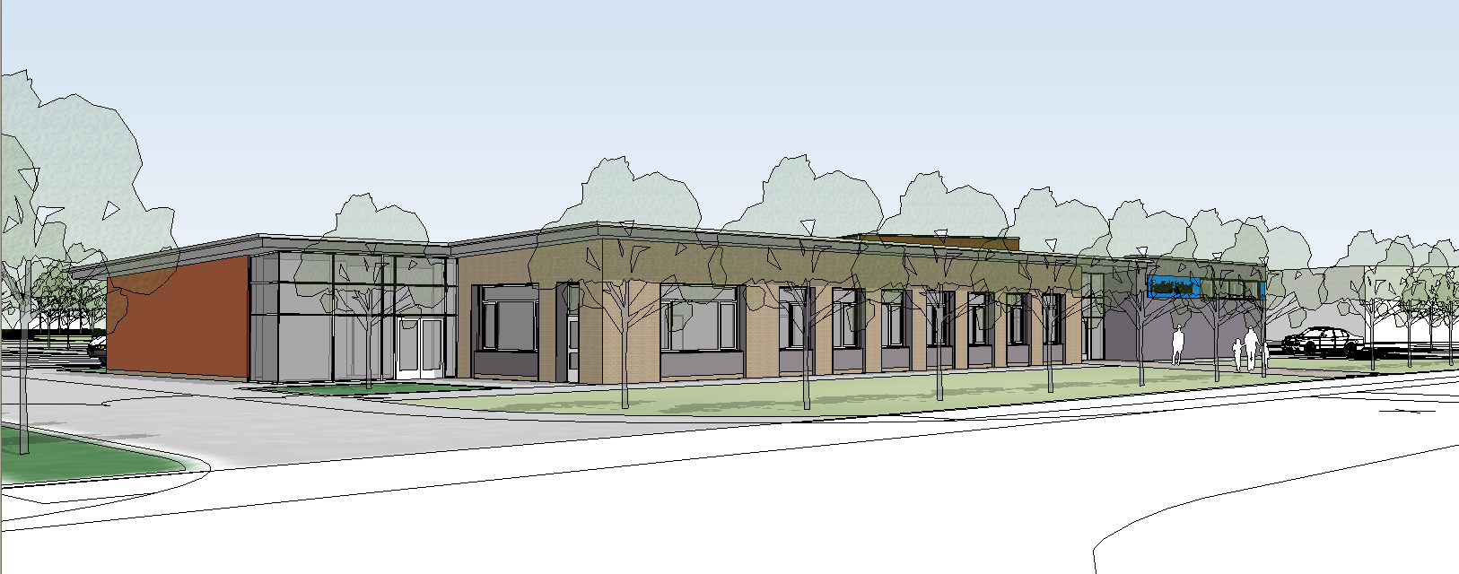
Additional Specific Support Assistants
2020

Additional specific support assistants can best be defined as:

Learning Support Assistants or Support Assistants specifically employed to provide additional support to a named pupil.

These staff, often referred to as “1:1 support” (although not always accurately) are employed by the LEA and are paid from its budget and not the school’s delegated budget. A.S.S.A.’s are employed to meet an identified need for a named pupil.

The provision of additional support can vary in terms of the amount of support provided, and the nature of the support assistant e.g. Learning Support Assistants, Support Assistants etc. These decisions are made by the LEA, having consulted with all of the appropriate parties, and this is subject to review as a part of the annual review of the

Statement of Special Educational Needs. In some cases the ASSA may
be recruited and appointed by the school on behalf of the LEA.

When the LEA deploys an ASSA at Foxfield School it is to enable the school to meet the needs of the named pupil. Therefore if the pupil’s needs change, or they leave the school then the position of the ASSA will be reviewed by the LEA.

A.S.S.A.’S AT FOXFIELD

A.S.S.A.’s are now directly employed by Foxfield School and are valued as an integral part of the team of school staff. Day to day management of the A.S.S.A.’s remains the responsibility of the Head teacher. Any concerns of problems that the member of staff has should be discussed with the head teacher.
On a day to day basis the class teacher will manage the A.S.S.A.’s working within the class. The teacher will decide how to most effectively use the additional support in order to meet the needs of the named pupil, as it is the responsibility of the class teacher to ensure that individual needs are met. The A.S.S.A. is not expected to work solely with the pupil for whom they are employed, or to spend all day with them. They are an integral part of the classroom staff, all of whom work to meet the various needs of the pupils in the group.

PROFESSIONAL DEVELOPMENT

The professional development needs of the A.S.S.A.’s working at Foxfield are given the same priority as the general Foxfield staff. This takes various forms including:

Induction period and support when starting at the school

A.S.S.A.’s will be given the same support when they come to work at Foxfield as permanent school staff. This is in line with the school’s induction policy, and will include guidance on school policies, staff handbook issues etc.

Annual professional development interview with the Head or Deputy.

Members of staff have the opportunity to discuss working conditions, training needs etc. This can lead to whole school or individual training and development work.

Changes in responsibility

In order to encourage professional development A.S.S.A.’s are given the opportunity to expand their experience of the range of pupils and curriculum delivered within the school. Through negotiation A.S.S.A.’s can change the groups of pupils they work with on a part time or full time basis, and develop skills from working with a wider range of pupils. The prime responsibility remains with meeting the needs of the individual for whom the A.S.S.A. is employed, and so any changes would need to ensure that this appropriate level of specific support is maintained. This professional development opportunity would be organised and approved by the Head teacher.

JOB DESCRIPTION

The A.S.S.A. are given a job description by the school that will outline their role, and indicates their responsibilities for a named pupil. This is reviewed annually.

All Learning Support Assistants and Support Assistants at Foxfield have a specific responsibility for an aspect of the school, the duties for which they complete within their directed hours. A.S.S.A.’s would also have a responsibility, the exact nature of which is open to negotiation with the Head teacher.

