Foxfield School

SMSC and British Values

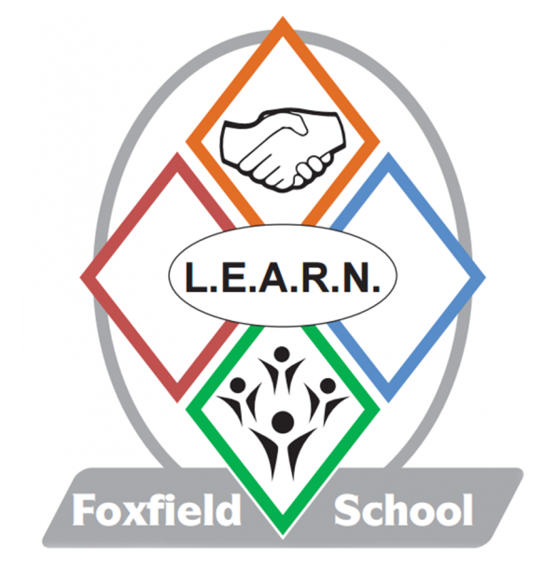

Introduction
At Foxfield school we recognise that the personal development of pupils, spiritual, moral, social and cultural education (SMSC) including British values plays a significant part in their ability to learn and achieve. It is supported and complemented by Religious Education, and PSHE. SMSC is a dimension of the whole school experience which makes the curriculum relevant, stimulating, creative and fun. It enriches the curriculum and the ethos of Foxfield School.

Aims

At Foxfield School we aim to provide an education that provides pupils with opportunities to explore and develop:

- their own values and beliefs,
- their self-knowledge, self-esteem and self-confidence;
- spiritual awareness,
- high standards of personal behaviour,
- the ability to distinguish right from wrong
- a positive, caring attitude towards other people,
- an understanding and appreciation of their own and others social and cultural traditions
- encourage students to accept responsibility for their behaviour, show initiative, and to understand how they can contribute positively to the lives of those living and working in the locality of the school and to society more widely;
- a broad general knowledge of and respect for public institutions and services in England;
- an understanding and respect for democracy and support for participation in the democratic processes

Spiritual development is when we:
Explore beliefs and experience; respect faiths, feelings and values; enjoy learning about oneself, others and the surrounding world; use imagination and creativity; reflect.

Moral development is when we:
Recognise right and wrong; respect the law; understand consequences; investigate moral and ethical issues; offer reasoned views.

Social development is when we:
Use a range of social skills; participate in the local community; appreciate diverse viewpoints; participate, volunteer and cooperate; resolve conflict; engage with the 'British values' of democracy, the rule of law, liberty, respect and tolerance.

Cultural development is when we:
Appreciate cultural influences; appreciate the role of Britain's parliamentary system; participate in culture opportunities; understand, accept, respect and celebrate diversity.
In our school pupil’s SMSC development is seen for example in:
- Taking part in a range of activities regarding social skills
- Developing an awareness and respect for diversity
- Developing and appreciation of theatre
- Developing an understanding of right and wrong.
- Developing the communication skills to make choices about likes/dislikes in school then in wider community visits.
- Taking part in sporting opportunities.
- Taking part in cultural opportunities.
- Taking part in artistic opportunities.
SMSC is embedded throughout the curriculum at Foxfield. This integrated approach ensures that aspects of SMSC is considered in all subject areas.

Please see appendix with overview of how we meet the needs

British Values

Our Values Statement

We promote ‘British Values’ through our spiritual, moral, social and cultural education which permeates through the school’s curriculum and supports the development of the ‘whole child’.

We recognise that such development is most successful when those values and attitudes are promoted by all the staff and provide a model of behaviour for our pupils.

The curriculum in all phases offers broad and balanced opportunities.

‘British Values’ have been identified as:

Democracy:

The ability to understand and communicate are the most important areas of learning. We ensure that pupils are given a ‘voice’ to communicate. This ‘voice’ could be using words, objects, photographs, pictures, symbols, touch cues, eye pointing or body language.

We empower our pupils by giving them opportunities to make choices about the things that they believe to be important. By valuing each ‘voice’ and by listening and responding to that voice we demonstrate that we support democracy and liberty.

We have an active School Council.

Rule of Law:

We involve pupils in setting codes of behaviour; helping pupils to make decisions and choices that are acceptable to the school community and society at large.

Pupils are helped to learn to manage their behaviour and take responsibility for their actions. Staff are committed to providing a consistent and predictable environment within the school and beyond. We can help some pupils to understand the connection between actions and consequences. This type of environment enables pupils to feel safe and secure; this in turn, promotes the optimum conditions for learning to take place.

Individual Liberty:

Pupils are encouraged to become good and valued citizens. We do this by supporting each pupil to become as independent as possible. We endeavour to demonstrate that everyone has rights; this includes the right to say 'Yes' or 'No' to ideas or activities. Some pupils will be able to take responsibility for particular roles and to understand that with certain rights comes a level of responsibility. Learning to do things independently is an important part of learning to understand yourself. We support others by participating in charitable events such as, Red Nose Day/Comic Relief and Children in Need. We believe that engendering a caring and helpful environment and to be independent can boost and nurture a healthy self-esteem.

Mutual Respect:

We promote each pupil’s inclusion in activities, settings and locations that are appropriate to them individually to meet their needs. Within school, pupils work with a range of people and interactions with others are always positively promoted on a personalised basis for each individual. This may include working with students from other schools, coaches from local clubs Everton and Liverpool, theatre groups etc. The curriculum is personalised and planned for pupils and may include transitioning within the range of resources and places on the site and going into the community to meet with a range of people in a variety of situations which include: sports events, community events and shared participation with other schools/colleges.

We believe it is important to facilitate opportunities to be part of the community as the pupils, families and staff have much to offer in the development of community cohesion.

Tolerance of different faiths and beliefs:

We are part of a school and local community where each person is respected and valued equally without regard to ability, gender, faith, heritage or race.

Cultural appreciation and development forms part of our curriculum. We place great emphasis on providing encounters and participation in events and celebrations to broaden all pupils’ experiences and awareness of others.

Our Assemblies help all pupils to find out about themselves and others linking their lives to the communities in which they belong. The themes cover areas such as: friendships, helping others and celebrations from a range of faiths and world events.

Pupils are encouraged to experience British Culture through our curriculum themes. For example, pupils have visited many local places. As a school, we take part in sporting activities which helps to instil ‘fair play’ and engender a ’team spirit’.

Although some of our pupils may find it difficult to articulate their feelings and concerns; staff are attuned to changes in demeanour and well-being that may indicate anxiety. If they are concerned about a pupil our accepted practice links to the Safeguarding Policy which entrusts a duty of care to all staff to actively protect and promote the welfare of children.

The staff work closely with parents, carers and other professionals to ensure that the pupils at Foxfield are happy, well cared for and enabled to learn the skills they need to live a fulfilling life as part of their community.

