The School has a number of systems in place to formally monitor the work of staff. These are complemented by the informal monitoring that occurs in most schools with cross-school movement of staff, close working relationships amongst colleagues and an open accessible management systems. One should not underestimate the value of this informal monitoring that can take place through conversations with pupils, staff and parents, or through senior staff regularly moving around the school and visiting classes.

The more formal monitoring procedures that are in place include:

Classroom observations
Carried out annually with all teachers and classes being visited at least once and a written summary of the monitoring produced and discussed. These were initially undertaken by the Head and Deputy, but in 1999 the senior teachers were introduced into the system ( with the Head and Deputies monitoring their work), as a part of a deliberate flatter management

Monitoring Policy 2020

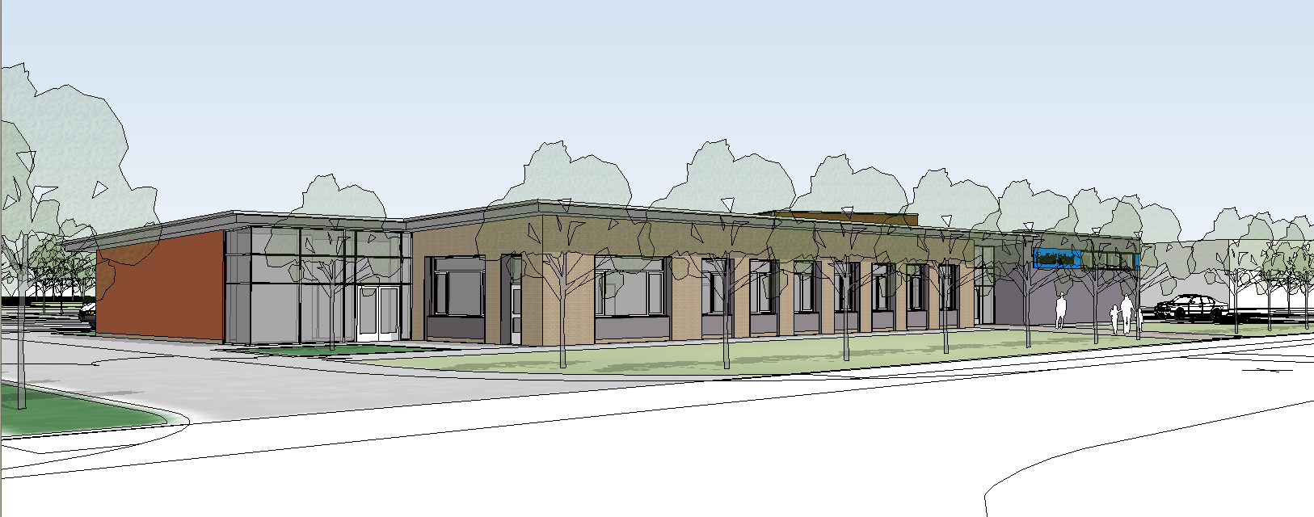

style. This also forms an important part of the professional development of senior teachers.

The formal observation and monitoring of teachers may look at their general performance or may focus on a
particular aspect of their work. For example in 1999 / 2000 the focus of monitoring was more specific, focussing on classroom planning and
preparation. This was to monitor the implementation of the new planning policy. Individual and whole teaching staff feedback was given, and the Headteacher followed this up by ‘spot
checks’ and working with specific colleagues where the monitoring by a
member of the Senior Management Team identified some concerns about quality.

One of the issues raised by the teachers and monitors has been the need for consistent judgements during classroom observations. As an attempt to address this in the autumn term 2000 the Senior Management Team worked through a training package that the school bought that aimed to develop classroom monitoring skills using the new OFSTED framework and looked at video of real lessons in special schools.

Classroom teaching / Subject Leader release time
Each half term the Head or a Deputy gives every teacher a double or triple lesson of additional release time to undertake subject leadership work. This provides two monitoring opportunities:

- The Head or a Deputy can judge classroom standards of display, organisation, pupil performance, and see pupil’s practical and recorded work. It also provides an opportunity to discuss concerns with the support staff in that group.

- The subject leader can undertake one of their specifically agreed responsibilities, i.e. monitoring the work of colleagues through observing classroom work, standards of planning, use of resources etc. A summary of the work the Subject Leaders undertake during this release time, including any monitoring should be produced and given to the Head .

All teachers also have a management responsibility to develop their individual area of the curriculum, including the updating of curriculum planning, policy documents etc. This work is monitored and co-ordinated by the Deputy Head for pupils and curriculum, who regularly feeds back to the Head. The Head also receives end of financial year spending evaluations and future spending plans from each Subject Leader, and an end of school year evaluation of overall subject development in July of each year that includes development priorities for the year ahead.

IEPs / Annual Reports and Reviews
IEPs are produced for each pupil twice a year and the reports and reviews undertaken annually. All of these are read and approved by the Head prior to being sent to parents. The Head will query any points that he is unsure of, or require clarification. When a new IEP is produced a summary of performance against previous targets is also sent home, and this gives another opportunity for the Head to monitor progress.

Parents are invited to contribute to the IEPs and Reviews using proformas that are sent home. These are all returned to the Headteacher who is able to monitor the parent’s satisfaction with the past and planned work for their child.

Monitoring of Teacher Record Keeping by the ARR coordinator
The Assessment, Recording and Reporting coordinator regularly checks the standards of recording within the Teacher Record Files and pupil’s Records of Achievement. He provides whole group and individual feedback. A copy of his monitoring records is checked by the Headteacher.

Teacher Record Files
From January 2005 teacher record files will contain assessment records for English, Maths, ILS and PSHE & Citizenship only as these tend to be the subjects taught by class teachers to their own groups. Subject coordinators will take responsibility for all the records for their subject and these will be stored in one file kept in a central location.

