Liaison and Transition
2020

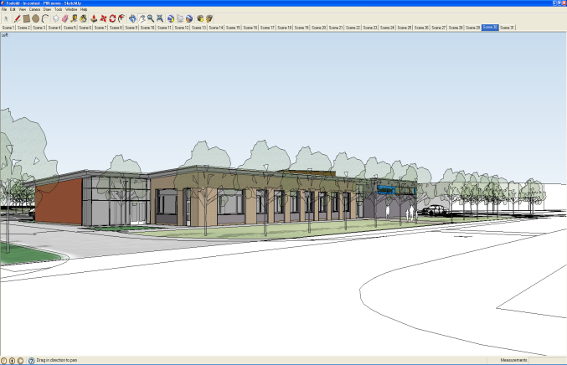

We believe that it is very important to have good liaison to enable schools in different phases to obtain a better understanding of each other's needs and problems and of the way in which each operates. The requirements of the National Curriculum mean that curriculum continuity, assessment procedures, recording and reporting, and the flow of information takes on an increased importance in the transition process.

We believe transition means the movement of pupils that takes place from one setting to another. We work hard to ensure that all children are supported in settling into their new learning environment in preparation for their future learning and development.

We want all children to achieve and to produce their very best and therefore we will ensure that the transition process runs smoothly in order for this to be achieved.

Aims

- To forge the best possible links between our local ‘feeder’ schools.
- To make the transition between phases and each Key Stage as smooth as possible for the pupils in our care so that

- the pace and quality of learning are maintained.
- To ensure that children continue to make the very best progress.
- To maintain regular and annual meetings to discuss various liaison issues.

- To create a common policy for pupil transfer information between phases.
- To work with our ‘feeder’ schools to share good practice in order to improve this policy.

Responsibility for the Policy and Procedure

Role of the Governing Body

The Governing Body has:

- appointed a member of staff to deal with all liaison and transitional issues;
- delegated powers and responsibilities to the Headteacher to ensure all school personnel and stakeholders are aware of and comply with this policy;
- responsibility for ensuring that the school complies with all equalities legislation;
- responsibility for ensuring this policy and all policies are maintained and updated regularly;
- responsibility for ensuring all policies are made available to parents;
- nominated a link governor to visit the school regularly, to liaise with the Headteacher and the coordinator and to report back to the Governing Body;
- responsibility for the effective implementation, monitoring and evaluation of this policy

Role of the Headteacher and Senior Leadership Team

The Headteacher and the Senior Leadership Team will:

- ensure all school personnel, pupils and parents are aware of and comply with this policy;

- work closely with the link governor and coordinator;
- provide leadership and vision in respect of equality;
- provide guidance, support and training to all staff;
- monitor the effectiveness of this policy;
- annually report to the Governing Body on the success and development of this policy

Role of the Coordinator

The coordinator will:

- lead the development of liaison and transition throughout the school;
- work closely with the Headteacher and the nominated governor;
- provide guidance and support to all staff;
- provide training for all staff on induction and when the need arises regarding;
- keep up to date with new developments and resources;
- undertake risk assessments when required;
- review and monitor;
- report to the Governing Body on the success and development of this policy

Role of School Personnel

School personnel will:

- comply with this policy to ensure that all children make the very best progress;
- bring to the attention of the coordinator any concerns they have on any aspect of this policy;
- attend regular liaison and transition meetings between phases;
- attend the end of year meeting for the ‘hand over’ of pupil information and records;
- attend meetings to moderate pupils work;

- be available during school time to discuss transitional issues with any concerned parent
- implement the school’s equalities policy and schemes;
- attend appropriate training sessions on equality;
- report any concerns they have on any aspect of the school community

Role of Parents/Carers

Parents/carers will:

- be aware of and comply with this policy;
- be asked to take part periodic surveys conducted by the school;
- support the school Code of Conduct and guidance necessary to ensure smooth running of the school

Parents will be invited to attend:

- an information meeting prior to their children moving between phases;
- curriculum workshops throughout the academic year;
- ‘Parents and Children Working Together’ events;
- parent-teacher consultations

Liaison and Transition Meetings

Termly liaison and transition meetings take place between all phases when a variety of issues are discussed and implemented.

Visits by Teachers

Visits by teachers from feeder classes to transitional classes and vice versa is encouraged.

Primary-Secondary Transition

The transition from any primary school to the secondary sector is a very important period in any child's life.

It our intention to make this transition as smooth as possible by:-

- arranging times for Y6 pupils to visit the secondary school and to work alongside their secondary colleagues;
- encouraging continuity in curriculum,
teaching styles and classroom
organisation;
- and encouraging the staff of the
secondary school to visit to discuss
pupil's progress

Moderation Meetings

Y6 teachers of the feeder primaries meet with Key Stage 3 teachers of Foxfield School in order to moderate pupils work so that a common understanding of levels is formed.

Taster Days

Y6 pupils are invited to spend some time at the Foxfield School in order to give them a real 'taste' of secondary school life.

