Lone Workers Policy
2020
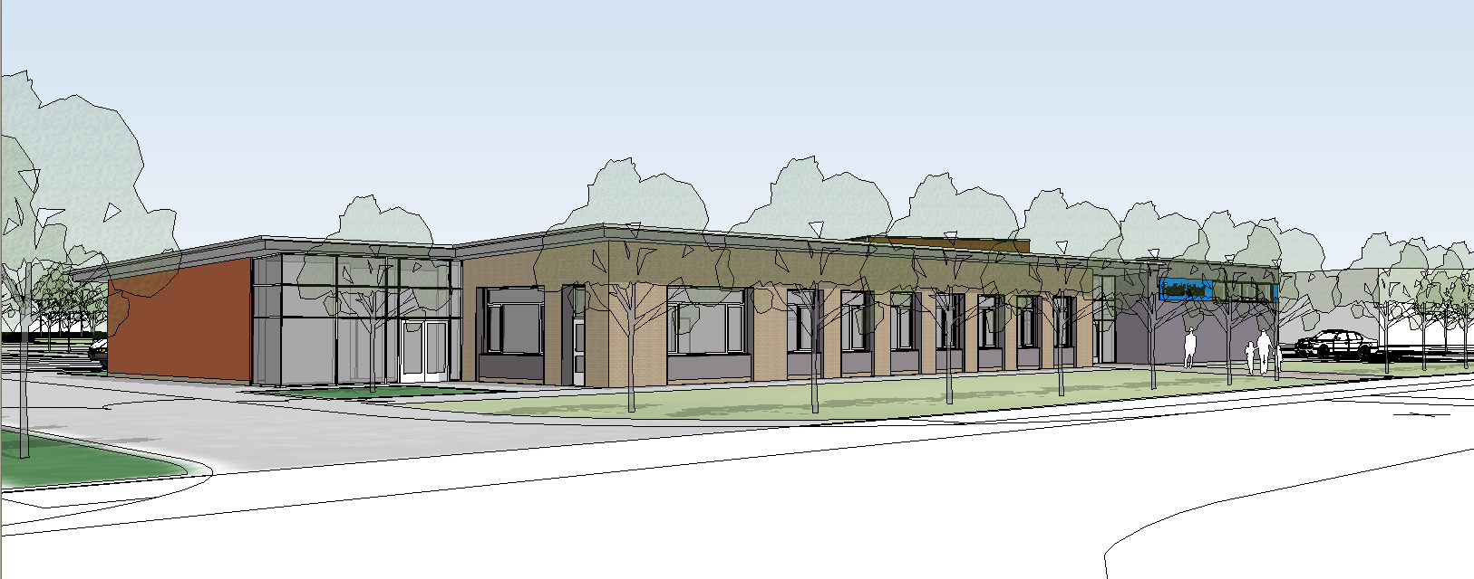

Lone Workers at Foxfield School

People falling into the category of lone workers include the following;

Caretaker
ICT Technician
ICT Support assistant
School Nurse
Language Support
Speech therapist
Occupational Therapist
Physiotherapist
LSA in charge of ILS base
Working on a one – to – one in the Sensory or Soft play rooms
Vision support
Hearing support
Gardener
Maintenance or building workers
Work experience support staff
Independent Travel Trainers
Inclusion Supervisors
Head teacher
Deputy Head teachers

Procedures for all staff when working after normal school hours should be as follows;

All lone workers
- Anyone working alone should make sure they have access to a telephone or have a personal mobile phone with them.

- Anyone intending to work late should check with the caretaker to see what time he intends to lock up the building

- When working alone in the building, the worker must inform the caretaker of their intention to work late and must inform the caretaker when they depart. A lone worker should also be able to contact the caretaker via the school Tannoy system or mobile phone.

Head teacher and Deputy Head teachers
It is possible that the Head teacher or the deputy will be working on site when the caretaker is not in the building. Therefore they will make sure they have access to a phone and will inform a relative or colleague of their intention to work in the building. On these occasions they should lock themselves in the building for reasons of security and health and safety.

The Caretaker
The caretaker is the most likely person to be working alone and in isolation after normal school hours and so would be deemed to be the most vulnerable on a regular basis.

- When the last person has left the building and notified the caretaker, he can then secure the building. Magnetic fire doors should be closed and
emergency lighting and exterior lights left on.

- When the caretaker arrives in the morning he must make a quick visual examination of the exterior of the building to make

sure that there are no signs of break-ins or that anyone may be in the building. If the caretaker is in any doubt he should contact Metro Security and should never enter the building if he is unsure of his safety.

- When the caretaker is a lone worker and in the building on his own, he must not climb ladders or undertake any potentially hazardous activities which may make him vulnerable

Loan workers outside school
This will include staff travelling on Independence in the community with small groups of pupils, work experience support staff, independent travel support staff, and staff travelling between educational sites.

All staff travelling outside the school must fill in an ‘Evolve’ form when with pupils or when on their own must sign out and let the secretary know of their destination and approximate time of return. Staff should also carry a mobile phone with which to contact the school if the need occurs.

Maintenance and building workers
See (All lone workers section).

Gardener
This is a daytime post only and so lone working after hours would not normally be a factor. However, the gardener should be guided by the following procedures.

- On arrival in school sign the visitor’s book
- Explain to a senior member of staff the daytime duties he intends to perform and discuss

safety factors and risk assessments involved with these duties.
- Let the secretary know the location around the grounds where he will be working.
- Inform the secretary if he intends to leave the site or go home early
- Inform the caretaker if he intends to work longer than the normal school day.
- Sign out in the visitor’s book when leaving the premises.

